**“ WEDDING MANAGEMENT WEBSITE”**

**Preface**

This project of **“ WEDDING MANAGEMENT WEBSITE”**of gives us the complete information about the library. We can enter the record of new books and retrieve the details of books available in the library. We can issue the books to the students and maintain their records and can also check how many books are issued and stock available in the library. In this project we can maintain the late fine of students who returns the issued books after the due date.

  Throughout the project the focus has been on presenting information and comments in an easy and intelligible manner. The project is very useful for those who want to know about Library Management System.

          In the last, we gratefully acknowledge and express our gratitude to all staff members of PRS Computer and friends who supported us in preparing this project

**Your name**

**INDEX**

|  |  |  |
| --- | --- | --- |
| **Sr. NO.** | TOPIC | **PAGE NO.** |
| **1** | **Preliminary Investigation** | **9** |
|  | (i) Project Overview | **10** |
|  | (ii) Description of System | **11** |
|  | (iii) Limitations of present system | **14** |
|  | (iv) Gantt Chart | **16** |
|  | (vi) Project schedule | **18** |
| **2** | **System Analysis** |  |
|  | 1. Functionality of system | **21** |
|  | 1. Use Case Diagram & 2. Use Case Description | **23** |
|  | 1. Sequence Diagram | **24** |
|  | 1. Collaboration diagram | **25** |
|  | 1. Class diagram | **27** |
|  | 1. State diagram | **28** |
|  | 1. Data Flow | **32** |
|  | 1. ERD | **34** |
| **3** | **System Design** |  |
|  | (i) Converting ERD to Tables | **33** |
|  | (ii) Design Class diagram[with UI classes, Persistent classes etc…] | **35** |
|  | (vi) Prg Flow charts & System flow chart | **42** |
| **4** | **System Coding** |  |
|  | (i) List of tables with attributes and constraints | **46** |
|  | (ii) Design Patterns used (if any) | **47** |
|  | (iii) Screen Layouts & Report Layouts | **49** |
|  | (iv) Coding | **55** |
| **5** | **Future Enhancements** | **58** |
| **6** | **References and Bibliography** | **59** |

**Title: “WEDDING MANAGEMENT WEBSITE”**

* **Abstract:**

Our Project is on **“WEDDING MANAGEMENT WEBSITE”**

Wedding planners **support couples and their families with the organisation, hiring, purchasing and management involved with planning a successful wedding**. For some clients, they will only be involved in specific aspects of the process, such as hiring caterers and entertainment or supporting on the day itself. Overall this project of ours is being developed to help the students as well as staff to maintain the wedding the best way possible and also reduce the human efforts.

* **Introduction :**
* **Wedding Planner Management System** is an online application, from which user can easily manage Booking details, Package details, Planner details. Admin can track all the information of Booking, Venue, Package ect. Admin can edit, add, delete and update the records of Planner, Blog, Payment.
* **Project Overview:**
  + - Online booking
    - Request the admin to edit the providing information.
    - A separate column for photos .
    - admin login page where admin can find booking issued by him/her(user) and verify if its valid or not.
    - A various type of options to choice for the marriage.
    - A admin page where admin can add any events being organized and important suggestions.

.

* **Purpose:**

The main purpose of this project is to develop a computerized system that will manage the activities for the marriage managment thereby providing easy access of organiszer how the event is goint to happen and when things are going to begen and end.  it will also help the organizer to keep track of marriage information etc. This system will also provide electronic means of storage and help librarians keep track of library information.

* **Objective and Scope of the project:**

* The main purpose of this website is to manage the management layout and take booking and explain the facility available with the booking.
* Using this website we can add new custom request to happen with the existing plan in the system and also edit.
* This website also have function of assign any request to the user.
* User can check there issued plans and get remainder to the it self.
* it’s a build of management infrastructure
* **Existing System:**

Existing system is a manual one in which users are maintaining books to store the information like product details , user detail , Distributors details, purchases, sales details and accounts for every month. It is very difficult to maintain historical data.

**Advantages:**

1. This website save the time as well as human efforts.
2. It uses to maintain Library Management
3. The system exclude the use of paper work by managing all the records electronically
4. The Library Management System is very flexible in use.
5. Provide accurate classification of books.

* **Reports Generation:**

Finally, from the system, book records can be generated as an output from the system. From these boo issue & return records, monthly or Yearly report of the library can be easily calculated.

* **No Special Training:**

No special training needed for using the system, anyone who doesn’t have accounting knowledge can use without any difficulty.

* **Methodology Adopted:**
* **Waterfall Model:**

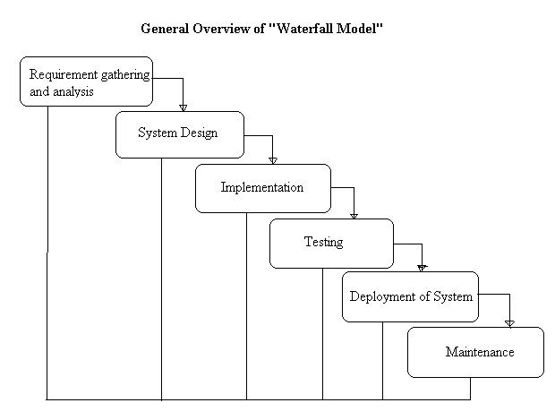

Waterfall approach was first a 'Process Model' to be introduced and followed widely in software engineering to ensure success of the project. In the waterfall approach, the whole process of software development is divided into separate phases. These phases in the model are:

**Requirement specifications phase  
Software design  
Implementation  
Testing and maintenance**

All these phases are cascaded to each other so that the second phase is started as and when a defined set of goals are achieved for first phase and it is signed off, and hence the peculiar name. All the methods and processes undertaken in the model are more visible.

**Stages of the Waterfall Model Explained**  
  
**Requirement Analysis and Definition**

All possible requirements of the system to be developed are captured in this phase. Requirements are a set of functions and constraints that the end user (who will be using the system) expects from the system. The requirements are gathered from the end user at the start of the software development phase. These requirements are analyzed for their validity, and the possibility of incorporating the requirements in the system to be developed is also studied. Finally, a requirement specification document is created which serves the purpose of guideline for the next phase of the model.  
  
**System and Software Design**

Before starting the actual coding phase, it is highly important to understand the requirements of the end user and also have an idea of how should the end product looks like. The requirement specifications from the first phase are studied in this phase and a system design is prepared. System design helps in specifying hardware and system requirements and also helps in defining the overall system architecture. The system design specifications serve as an input for the next phase of the model.  
  
**Implementation and Unit Testing**

On receiving system design documents, the work is divided in modules/units and actual coding is started. The system is first developed in small programs called units, which are integrated in the next phase. Each unit is developed and tested for its functionality; this is referred to as unit testing. Unit testing mainly verifies if the modules/units meet their specifications.

**Integration and System Testing**

As specified above, the system is first divided into units which are developed and tested for their functions. These units are integrated into a complete system during integration phase and tested to check if all modules/units coordinate with each other, and the system as a whole behaves as per the specifications. After successfully testing the software, it is delivered to the customer.  
  
  
**Operations & Maintenance**  
This phase of the model is virtually a never-ending phase. Generally, problems with the system developed (which are not found during the development life cycle) come up after its practical use starts, so the issues related to the system are solved after deployment of the system. Not all the problems come into picture directly but they arise from time to time and need to be solved; hence this process is referred to as maintenance.  
  
**Advantages**

There is clear compartmentalization of work and control in the model. Since there is compartmentalization, it is easier to set schedule for the tasks to be completed within a specified time period.

The other advantage of this model is that only after the work for a particular phase is over, does the other phase start, due to which there is no overlapping of phases or the product does not have to go through different iterative steps.

This model is the easiest to implement in the eyes of most of the mangers, due to its linear model. Since the processes of this model are carried out in linear manner, the cost of resources is reduced to a large extent, which in turn helps in reducing the cost of the project considerably.  
Lastly, the documentation and testing happens at the end of each phase, which helps in maintaining the quality of the project.

**Disadvantages**  
  
As it is very important to gather all possible requirements during the requirement gathering and analysis phase in order to properly design the system, not all requirements are received at once, the requirements from customer goes on getting added to the list even after the end of .The problems with one phase are never solved completely during that phase and in fact many problems regarding a particular phase arise after the phase is signed off, this results in badly structured system as not all the problems (related to a phase) are solved during the same phase.  
As the requirements of the customer go on getting added to the list, not all the requirements are fulfilled, this results in development of almost unusable system. These requirements are then met in the newer version of the system; this increases the cost of system development.

Although there are a few disadvantages of the model, it continues to be one of the widely-used software development approach in the industry. This can be attributed to the fact, that the advantages of this model outweigh its disadvantages in certain kind of projects. And lastly, if the team does not have a lot of experience, this model perfectly serves the purpose.

* **Gantt Chart:**
* A gantt chart is simply a timeline view of your project. The left hand side is a list of tasks for your project organized into groups. The image below is an example of a gantt chart that could be used to plan a concert.
* Gantt charts are especially useful for any project where you want to visualize how long your project will take. You can also link tasks together by creating dependencies between tasks. This ensures that tasks are done in the correct order. He was able to really get a grip on his project and keep it under control.
* Another great advantage that gantt charts provide is the ability to see who is doing what and when they are doing it. This allows for better project planning by efficiently assigning tasks to people on your team and scheduling them according to their current workload. Gantt charts have become a common technique for representing the phases and activities of a project because so they can be understood by a wide audience
* The Gantt chart allows the project team, as well as the stakeholders, to visualize the schedule and to determine the completion date. During the project, the project manager can determine whether the project is on schedule at any point during the execution. If changes occur, the project team can utilize the Gantt chart to determine how the changes will affect the completion date. There are various software packages that can create Gantt charts, but one that is more widely used is Microsoft Project is a powerful tool that can create sophisticated Gantt charts as well as other planning diagrams.

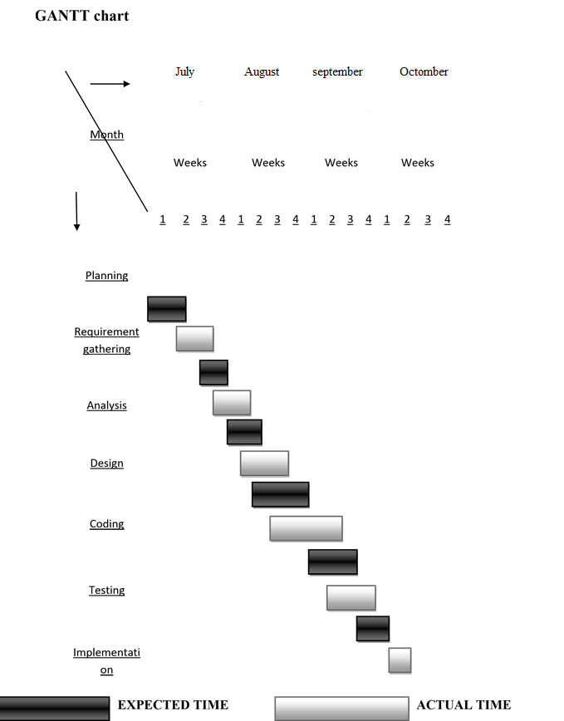

|  |  |  |  |  |  |
| --- | --- | --- | --- | --- | --- |
| * **PROJECT SCHEDULE**   **Project Title**: “MARRIAGE MANAGEMENT SYSTEM”  **FrontEnd/ Back End: HTML,CSS,JAVASCRIPT ,PHP / SQLLITE** | | | | | |
| **Sr.No** | **Contents** | **Proposed date** | **Submission Date** | **Teacher`s sign** | **Remark** |
| **1** | **Investigation** | **-** | **-** | **-** | **-** |
|  | Project fixing |  |  |  |  |
|  | Synopsis |  |  |  |  |
| **2** | **Analysis** | **-** | **-** | **-** | **-** |
|  | Project history |  |  |  |  |
|  | Requirement Gathering |
|  | Objective And Scope of Project |
|  | Problems With Existing System |
|  | Advantage Of Proposed System |
|  | Feasiblity Study |  |  |  |  |
|  | Cost Benefit Analysis |  |  |  |
|  | Requirement Specification |  |  |  |
|  | Tools & Technology |  |  |  |
| **3** | **Design phase** | **-** | - | - | - |
|  | Detailed Life Cycle Of Project(Logical Design) |  |  |  |  |
|  | Class Diagram |  |  |  |
|  | E-R Diagram |  |  |  |
|  | Event Table |  |  |  |
|  | Use Case Diagram |  |  |  |
| **4** | **Coding phase** | **-** | - | - | - |
|  | Data base Design (with proper records) |  |  |  |  |
|  | Forms |  |  |  |  |
|  | Modules Design |  |  |  |  |
|  | Validating Forms/ applications |  |  |  |
| **5** | **Testing phase** | **-** | - | - | - |
|  | Module Testing/ unit testing |  |  |  |  |
|  | Integration Testing |  |  |  |  |
|  | System Testing |  |  |  |
|  | Acceptance testing |  |  |  |
| **6** | **Maintenace and evaluation** | **-** | - | - | - |
|  | System Maintainace And Future Enhancement |  |  |  |  |
|  | User Manual/ help report |  |  |  |
| **7** | **Review** |  |  |  |  |
| **8** | **Project / Black book & Back up softcopy submission** |  |  |  |  |

* **REQUIREMENT ANALYSIS:**

Requirement analysis is the process of gathering and analyzing user requirements. It is done prior to starting the actual project development.

It may also be defined as a condition of capabilities needed by the user to solve the problem or achieve an objective and also a condition or capability that must be met or proposed a contract, standard specification or other formal imposed documents.

* It is simple, easy to understand software interface.
* Enables the user to retrieve transactions in real time.
* Enables generation of reports to get the summary.
* Enables backup and restore facility.

**DIAGRAMS**

**INTRODUCTION:**

Design is the first step in the development phase for any techniques and principles for the purpose of defining a device, a process or system in sufficient detail to permit its physical realization.

Once the software requirements have been analyzed and specified the software design involves three technical activities - design, coding, implementation and testing that are required to build and verify the software.

The design activities are of main importance in this phase, because in this activity, decisions ultimately affecting the success of the software implementation and its ease of maintenance are made. These decisions have the final bearing upon reliability and maintainability of the system. Design is the only way to accurately translate the customer’s requirements into finished software or a system.

Design is the place where quality is fostered in development. Software design is a process through which requirements are translated into a representation of software. Software design is conducted in two steps. Preliminary design is concerned with the transformation of requirements into data.

UML Diagrams:

**Use Case Scenario:**

In above library system project there are two users Librarian and Student. Both Librarian and Student can do all activities after login in to library management system.

### USER Activity :

* Input personal details
* Add booking
* Add date of marraige
* Add plan.
* Issue the booking

### Admin Activity :

* Search for the booking
* Verify the booking is fake for real
* Penalty Report
* Change the user plans
* Edit the user plans and details
* Plan the marriage for a customs.
* **Use Case Description**:

Use case describes the behavior of a system from user’s point of view. It provides functional description of a system and its major processes. It provides graphical description of users of system and what kind of interaction takes place within the system.

In this project, initially, user comes for giving purchase order for different products. All information about the products which are available are provided to the customer in this site . Customer try different products, if satisfied buy that product. Then the full payment is done by customer. Manager then enters the record of customer in the database. The stock is updated by entering the record in sale . Final reports are generated by manager and stored at the site.

**Symbols used in Use Case diagram:**

- It describes the name of an **actor**. An **actor** in a use case diagram interacts with a use case.

- It gives the actual **use case name**. Each use case is a system of transaction performed by the system.

- It is known as association. It is used to show the participation of actor in use case.

UML stands for Unified Modeling Language. UML is a language for specifying, visualizing and documenting the system. This is the step while developing any product after analysis. The goal from this is to produce a model of the entities involved in the project which later need to be built. The representation of the entities that are to be used in the product being developed need to be designed.

There are various kinds of methods in software design:

They are as follows:

* Use case Diagram
* Sequence Diagram
* Collaboration Diagram
* Activity Diagram
* State chat Diagram

**USECASE DIAGRAMS:**

Use case diagrams model behavior within a system and helps the developers understand of what the user require. The stick man represents what’s called an actor.

Use case diagram can be useful for getting an overall view of the system and clarifying who can do and more importantly what they can’t do.

Use case diagram consists of use cases and actors and shows the interaction between the use case and actors.

* The purpose is to show the interactions between the use case and actor.
* To represent the system requirements from user’s perspective.
* An actor could be the end-user of the system or an external system.

**USECASE DIAGRAM:**

A Use case is a description of set of sequence of actions. Graphically it is rendered as an ellipse with solid line including only its name. Use case diagram is a behavioral diagram that shows a set of use cases and actors and their relationship. It is an association between the use cases and actors. An actor represents a real-world object. Primary Actor – Sender, Secondary ActorReceiver.

**Fig.1. Use Case Diagram**

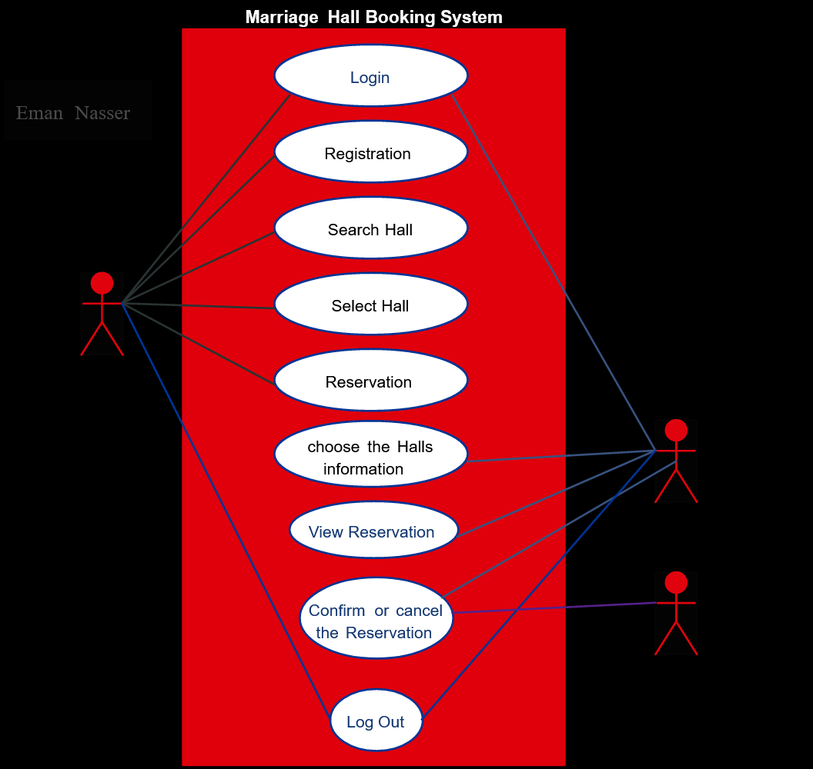

* **SEQUENCE DIAGRAM:**

Sequence diagram and collaboration diagram are called INTERACTION DIAGRAMS. An interaction diagram shows an interaction, consisting of set of objects and their relationship including the messages that may be dispatched among them.

A sequence diagram is an introduction that empathizes the time ordering of messages. Graphically a sequence diagram is a table that shows objects arranged along the X-axis and messages ordered in increasing time along the Y-axis.

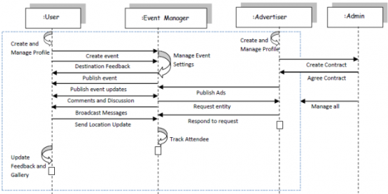

**Fig.2. Sequence Diagram**

* **COLLABORATION DIAGRAM:**

A collaboration diagram is an introduction diagram that emphasizes the structural organization of the objects that send and receive messages. Graphically a collaboration diagram is a collection of vertices and arcs.

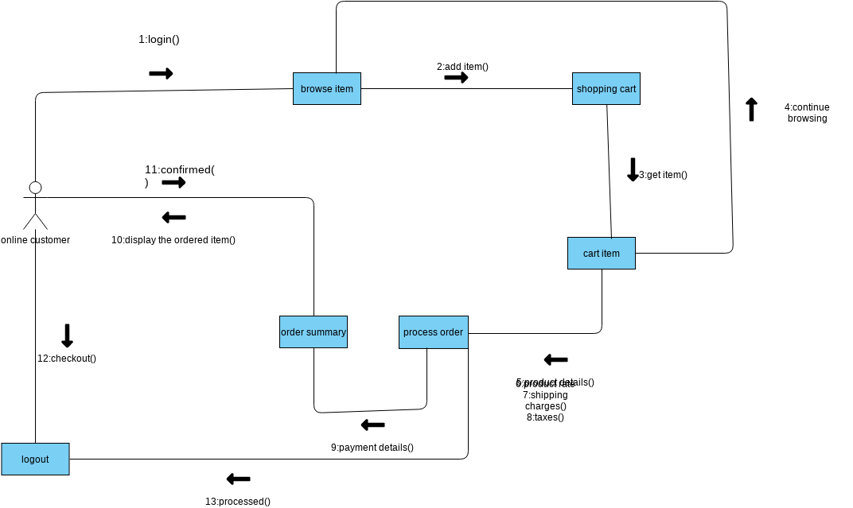**Fig.3.Collaboration Diagram**

* **CLASS DIAGRAM:**

Class is nothing but a structure that contains both variables and methods. The Class Diagram shows a set of classes, interfaces, and collaborations and their relating ships. There is most common diagram in modeling the object oriented systems and are used to give the static view of a system. It shows the dependency between the classes that can be used in our system.

The interactions between the modules or classes of our projects are shown below. Each block contains Class Name, Variables and Methods.

In [software engineering](http://en.wikipedia.org/wiki/Software_engineering), a **class diagram** in the [Unified Modeling Language](http://en.wikipedia.org/wiki/Unified_Modeling_Language) (UML) is a type of static structure diagram that describes the structure of a system by showing the system's [classes](http://en.wikipedia.org/wiki/Class_(computer_science)), their attributes, operations (or methods), and the relationships among the classes. The class diagram is the main building block of [object oriented](http://en.wikipedia.org/wiki/Object_oriented) modelling. It is used both for general [conceptual modelling](http://en.wikipedia.org/wiki/Conceptual_model) of the systematic of the application, and for detailed modelling translating the models into [programming code](http://en.wikipedia.org/wiki/Programming_code). Class diagrams can also be used for [data modeling](http://en.wikipedia.org/wiki/Data_modeling).[[1]](http://en.wikipedia.org/wiki/Class_diagram#cite_note-1) The classes in a class diagram represent both the main objects, interactions in the application and the classes to be programmed. A class with three sections.

In the diagram, classes are represented with boxes which contain three parts

* The upper part holds the name of the class
* The middle part contains the attributes of the class
* The bottom part gives the methods or operations the class can take or undertake

In the design of a system, a number of classes are identified and grouped together in a class diagram which helps to determine the static relations between those objects. With detailed modeling, the classes of the conceptual design are often split into a number of subclasses.

* **CLASS:**

A description of set of objects that share the same attributes, operations, relationships, and semantics

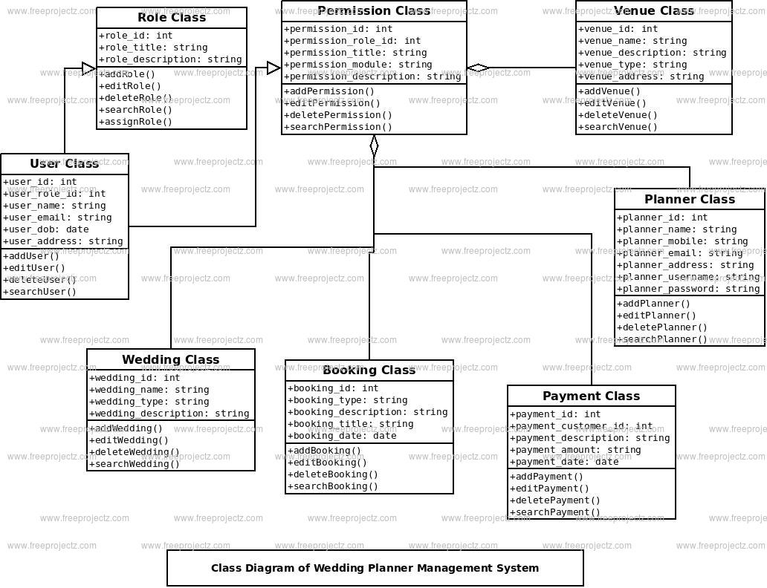

**Fig.4.Class Diagram**

* **State chart diagram**

**Fig.5.State Chart Diagram**

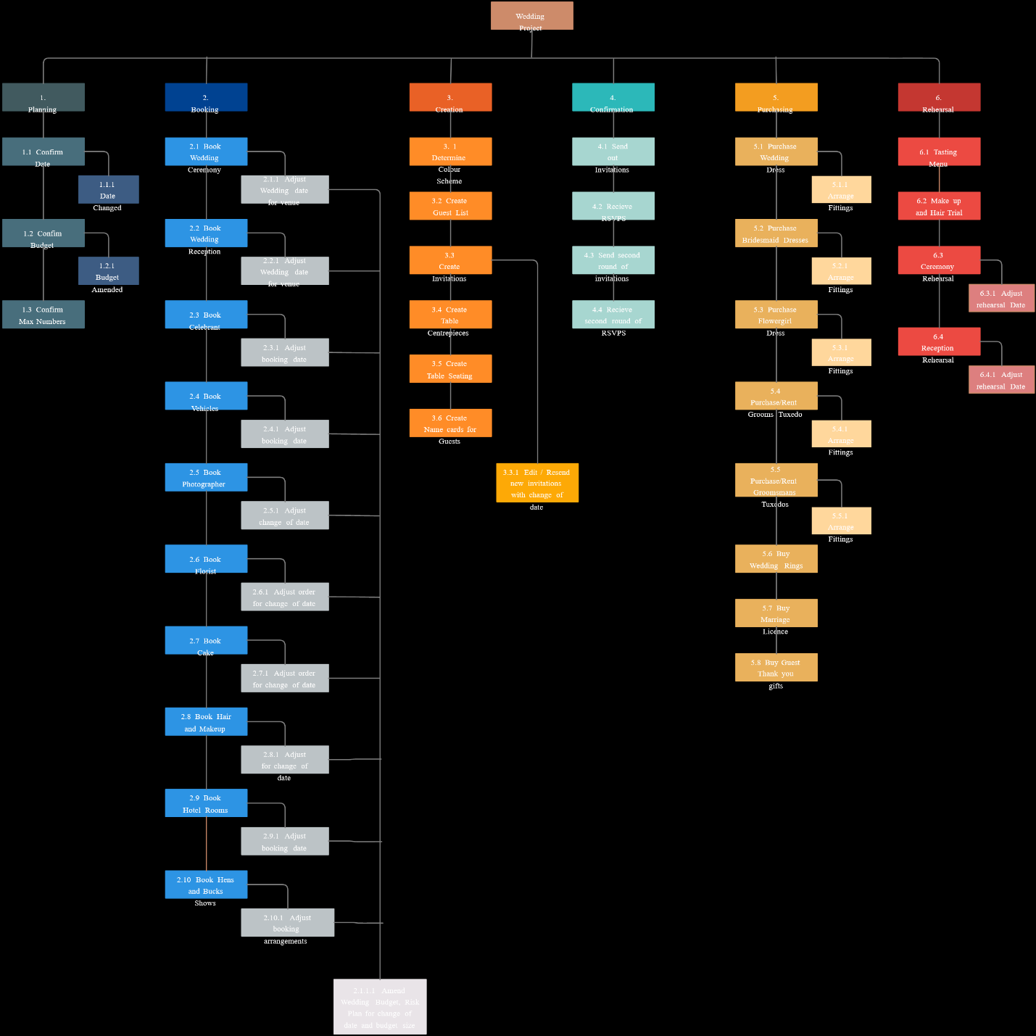

* **DATA FLOW DIAGRAMS**:

The DFD takes an input-process-output view of a system i.e. data objects flow into the software, are transformed by processing elements, and resultant data objects flow out of the software.

Data objects represented by labeled arrows and transformation are represented by circles also called as bubbles. DFD is presented in a hierarchical fashion i.e. the first data flow model represents the system as a whole. Subsequent DFD refine the context diagram (level 0 DFD), providing increasing details with each subsequent level.

The DFD enables the software engineer to develop models of the information domain & functional domain at the same time. As the DFD is refined into greater levels of details, the analyst perform an implicit functional decomposition of the system. At the same time, the DFD refinement results in a corresponding refinement of the data as it moves through the process that embody the applications.

A context-level DFD for the system the primary external entities produce information for use by the system and consume information generated by the system. The labeled arrow represents data objects or object hierarchy.

**RULES FOR DFD:**

* Fix the scope of the system by means of context diagrams.
* Organize the DFD so that the main sequence of the actions
* Reads left to right and top to bottom.
* Identify all inputs and outputs.
* Identify and label each process internal to the system with Rounded circles.
* A process is required for all the data transformation and Transfers. Therefore, never connect a data store to a data Source or the destinations or another data store with just a Data flow arrow.
* Do not indicate hardware and ignore control information.
* Make sure the names of the processes accurately convey everything the process is done.
* There must not be unnamed process.
* Indicate external sources and destinations of the data, with Squares.
* Number each occurrence of repeated external entities.
* Identify all data flows for each process step, except simple Record retrievals.
* Label data flow on each arrow.
* Use details flow on each arrow.
* Use the details flow arrow to indicate data movements.

**x**

* **Technologies used :**

**Front-End:**

# OVERVIEW OF TECHNOLOGIES USED

# Front End Technology

# PHP

The PHP Framework is a new computing platform that simplifies application development in the highly distributed environment of the Internet. The PHP Framework is designed to fulfill the following objectives:

* To provide a consistent object-oriented programming environment whether object code is stored and executed locally, executed locally but Internet-distributed, or executed remotely.
* To provide a code-execution environment that minimizes software deployment and versioning conflicts.
* To provide a code-execution environment that guarantees safe execution of code, including code created by an unknown or semi-trusted third party.
* To provide a code-execution environment that eliminates the performance problems of scripted or interpreted environments.
* To make the developer experience consistent across widely varying types of applications, such as Windows-based applications and Web-based applications.
* To build all communication on industry standards to ensure that code based on the .NET Framework can integrate with any other code.

The PHP Framework has two main components: the common language runtime and the PHP Framework class library. The common language runtime is the foundation of the PHP Framework. You can think of the runtime as an agent that manages code at execution time, providing core services such as memory management, thread management, and remoting, while also enforcing strict type safety and other forms of code accuracy that ensure security and robustness. In fact, the concept of code management is a fundamental principle of the runtime. Code that targets the runtime is known as managed code, while code that does not target the runtime is known as unmanaged code. The class library, the other main component of the PHP Framework, is a comprehensive, object-oriented collection of reusable types that you can use to develop applications ranging from traditional command-line or graphical user interface (GUI) applications to applications based on the latest innovations provided by ASP.NET, such as Web Forms and XML Web services.

The PHP Framework can be hosted by unmanaged components that load the common language runtime into their processes and initiate the execution of managed code, thereby creating a software environment that can exploit both managed and unmanaged features. The PHP Framework not only provides several runtime hosts, but also supports the development of third-party runtime hosts.

For example, PHP hosts the runtime to provide a scalable, server-side environment for managed code. PHP works directly with the runtime to enable Web Forms applications and XML Web services, both of which are discussed later in this topic.

Internet Explorer is an example of an unmanaged application that hosts the runtime (in the form of a MIME type extension). Using Internet Explorer to host the runtime enables you to embed managed components or Windows Forms controls in HTML documents. Hosting the runtime in this way makes managed mobile code (similar to Microsoft® ActiveX® controls) possible, but with significant improvements that only managed code can offer, such as semi-trusted execution and secure isolated file storage.

The following illustration shows the relationship of the common language runtime and the class library to your applications and to the overall system. The illustration also shows how managed code operates within a larger architecture.

## .NET Framework Class Library

The . PHP Framework class library is a collection of reusable types that tightly integrate with the common language runtime. The class library is object oriented, providing types from which your own managed code can derive functionality. This not only makes the .NET Framework types easy to use, but also reduces the time associated with learning new features of the PHP Framework. In addition, third-party components can integrate seamlessly with classes in the . PHP Framework.

For example, the .NET Framework collection classes implement a set of interfaces that you can use to develop your own collection classes. Your collection classes will blend seamlessly with the classes in the PHP Framework.

As you would expect from an object-oriented class library, the . PHP Framework types enable you to accomplish a range of common programming tasks, including tasks such as string management, data collection, database connectivity, and file access. In addition to these common tasks, the class library includes types that support a variety of specialized development scenarios. For example, you can use the PHP Framework to develop the following types of applications and services:

* Console applications.
* Scripted or hosted applications.
* Windows GUI applications (Windows Forms).
* PHP applications.
* XML Web services.
* Windows services.

For example, the Windows Forms classes are a comprehensive set of reusable types that vastly simplify Windows GUI development. If you write an ASP.NET Web Form application, you can use the Web Forms classes.

# SOFTWARE METHODOLOGY

The software methodology followed in this project includes the object-oriented methodology and the application system development methodologies. The description of these methodologies is given below.

Application System Development – A Life cycle Approach

Although there are a growing number of applications (such as decision support systems) that should be developed using an experimental process strategy such as prototyping, a significant amount of new development work continue to involve major operational applications of broad scope. The application systems are large highly structured. User task comprehension and developer task proficiency is usually high. These factors suggest a linear or iterative assurance strategy. The most common method for this stage class of problems is a system development life cycle modal in which each stage of development is well defined and has straightforward requirements for deliverables, feedback and sign off. The system development life cycle is described in detail since it continues to be an appropriate methodology for a significant part of new development work.

The basic idea of the system development life cycle is that there is a well-defined process by which an application is conceived and developed and implemented. The life cycle gives structure to a creative process. In order to manage and control the development effort, it is necessary to know what should have been done, what has been done, and what has yet to be accomplished. The phrases in the system development life cycle provide a basis for management and control because they define segments of the flow of work, which can be identified for managerial purposes and specifies the documents or other deliverables to be produced in each phase.

The phases in the life cycle for information system development are described differently by different writers, but the differences are primarily in the amount of necessity and manner of categorization. There is a general agreement on the flow of development steps and the necessity for control procedures at each stage.

The information system development cycle for an application consists of three major stages.

1. Definition.
2. Development.
3. Installation and operation.

The first stage of the process, which defines the information requirements for a feasible cost effective system. The requirements are then translated into a physical system of forms, procedures, programs etc., by the system design, computer programming and procedure development. The resulting system is test and put into operation. No system is perfect so there is always a need for maintenance changes. To complete the cycle, there should be a post audit of the system to evaluate how well it performs and how well it meets the cost and performance specifications. The stages of definition, development and installation and operation can therefore be divided into smaller steps or phrases as follows.

**Definition**

Proposed definition : preparation of request for proposed applications.

Feasibility assessment : evaluation of feasibility and cost benefit of proposed system.

Information requirement analysis : determination of information needed.

**Design**

Conceptual design : User-oriented design of application development.

Physical system design : Detailed design of flows and processes in applications processing system and preparation of program specification.

Development

Program development : coding and testing of computer programs.

Procedure development : design of procedures and preparation of user instructions.

**Installation and operation**

Conversion : final system test and conversion.

Operation and maintenance : Month to month operation and maintenance

Post audit : Evaluation of development process, application system and results of use at the completion of the each phase, formal approval sign-off is required from the users as well as from the manager of the project development.

* **Hardware And Software Requirements:**
* **Hardware Requirements:**

1. Processor: Intel i5
2. RAM: 16GB.

3. HDD: 150 GB.

* **Software Requirements:**

1. Operating Systems Windows XP (Professional edition), Windows 7 or higher operating system.
2. Front End: html, css, javascript, php.
3. Back End: Microsoft SQL lite 2020

* **Modules:**

**MODULES :** This project contains 3 modules, those are

1. **Login**
2. **liberian**
3. **student**

**MODULES DESCRIPTION**

FUNCTIONAL REQUIREMENTS

ADMIN LOGIN

* LOGIN
* Description of feature

This feature used by the user to login into system. They are required to enter user id and password before they are allowed to enter the system .The user id and password will be verified and if invalid id is there user is allowed to not enter the system.

* Functional requirements
  + - -Admin id and password is made with super user.
    - -The system must only allow user with valid id and password to enter the system
    - -The system performs authorization process which decides what user level can acess to.
    - -The user must be able to logout after they finished using system.
* **Feasibility Study**
* ***Feasibility*:** A measure of how beneficial or practical the development of information system would be to an organization can be termed as Project Feasibility.
* Feasibility analysis is the process by which feasibility is measured.
* Feasibility should be measured throughout the life cycle. The scope and complexity of an apparently feasible project can change after the initial problems and opportunities are fully analyzed after the system has been designed. Thus, a project that is feasible at one point may become infeasible later.

**The checkpoints for feasibility study are: -**

* **A survey phase checkpoint**
* **A study phase checkpoint.**
* **A definition phase checkpoint**
* **A selection phase checkpoint.**
* **Procurement phase checkpoint.**
* **Design phase checkpoint**

Generally there are following areas of risk for a new system that are

Considered when confirming project feasibility:

1. **Operational feasibility/Organizational and cultural feasibility**

It is measure of how well the solution will work in the organization. It is also a measure of how people feel about the system or project.

This project is well developed based on the customs and culture followed by the organization and it is easy to use. So it is operationally and culturally feasible**.**

1. **Economic feasibility**

It is a measure of cost-effectiveness of a project or solution. This is often called **a cost-benefit analysis**. This project is economically feasible because it is with minimal of cost.

**2.Technical feasibility**

Itis a measure of how the practicality of a specific technical solution and the availability of technical resources and expertise. By using this software, it is easy to enter the details of Order as well as the details of master forms. In addition to this, calculation of salary and commission is also possible using this software.

**3.Schedule feasibility**

It is a measure of how responsible the project timetable is. According to the organization, this software they have to use commercially in the next economical year. So the schedule can be managed as they give enough time to build this software.

* **Acceptance Testing**
* **Acceptance testing** is a test conducted to determine if the requirements of a [specification](http://en.wikipedia.org/wiki/Specification) or [contract](http://en.wikipedia.org/wiki/Contract) are met. It may involve [chemical tests](http://en.wikipedia.org/wiki/Chemical_test), [physical tests](http://en.wikipedia.org/wiki/Physical_test), or [performance tests](http://en.wikipedia.org/wiki/Performance_test_(assessment)).
* In [systems engineering](http://en.wikipedia.org/wiki/Systems_engineering) it may involve [black-box testing](http://en.wikipedia.org/wiki/Black-box_testing) performed on a [system](http://en.wikipedia.org/wiki/System) (for example: a piece of [software](http://en.wikipedia.org/wiki/Software_system), lots of manufactured mechanical parts, or batches of chemical products) prior to its delivery.
* Software developers often distinguish acceptance testing by the system provider from acceptance testing by the [customer](http://en.wikipedia.org/wiki/Customer) (the user or client) prior to accepting transfer of ownership. In the case of software, acceptance testing performed by the customer is known as [user acceptance testing](http://en.wikipedia.org/wiki/Acceptance_testing#User_acceptance_testing) (UAT), end-user testing, site (acceptance) testing, or field (acceptance) testing.
* environment or feature of the system, and will result in a pass or fail outcome. There is generally no degree of success or failure. The test environment is usually designed to be identical, or as close as possible, to the anticipated user's environment, including extremes of such.

# White-box testing:

White box testing focus on the program control structure. Test cases are derived to ensure that all statements in the program have been executed at least once during testing and that all logical conditions have been executed.

# Block-box testing:

Black box testing is designed to validate functional requirements without regard to the internal workings of a program. Black box testing mainly focuses on the information domain of the software, deriving test cases by partitioning input and output in a manner that provides through test coverage. Incorrect and missing functions, interface errors, errors in data structures, error in functional logic are the errors falling in this category.

* **DATA ENTRY SCREEN**
* **Home Page:**

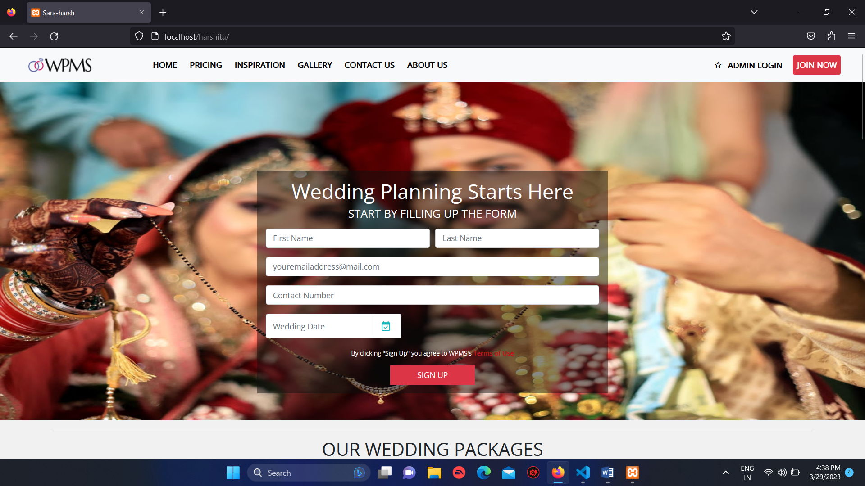

* 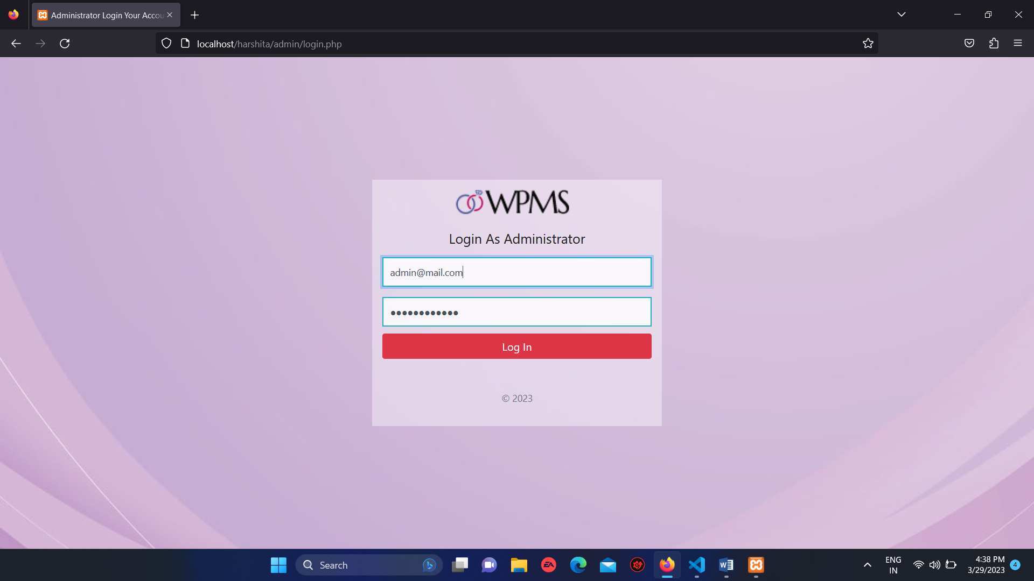**Admin Page:**
* **Gallery**

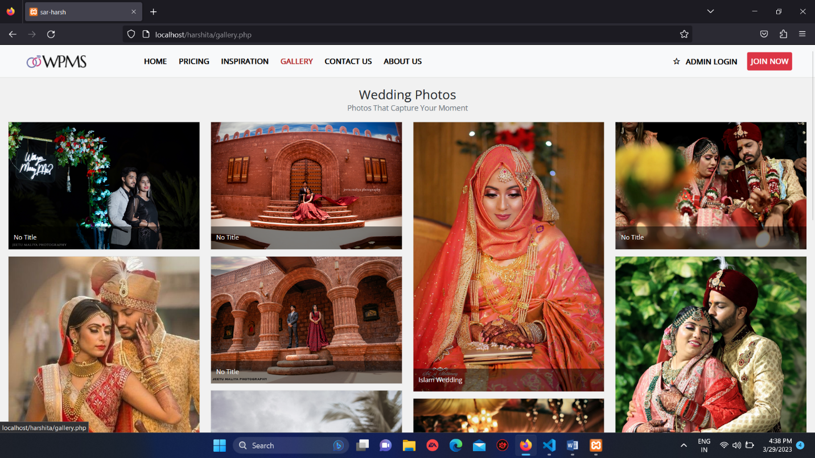

* **INSPIRATION PAGE**

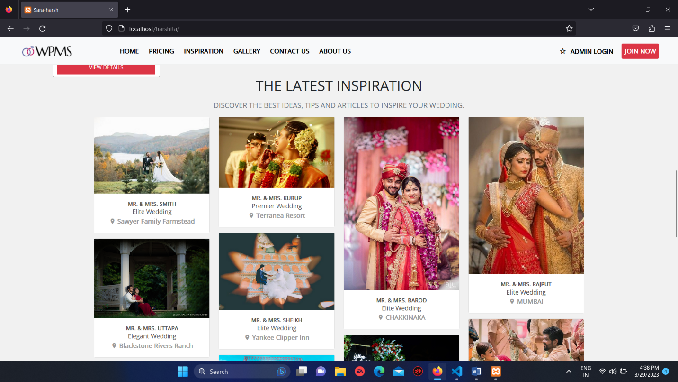

* **Admin page**

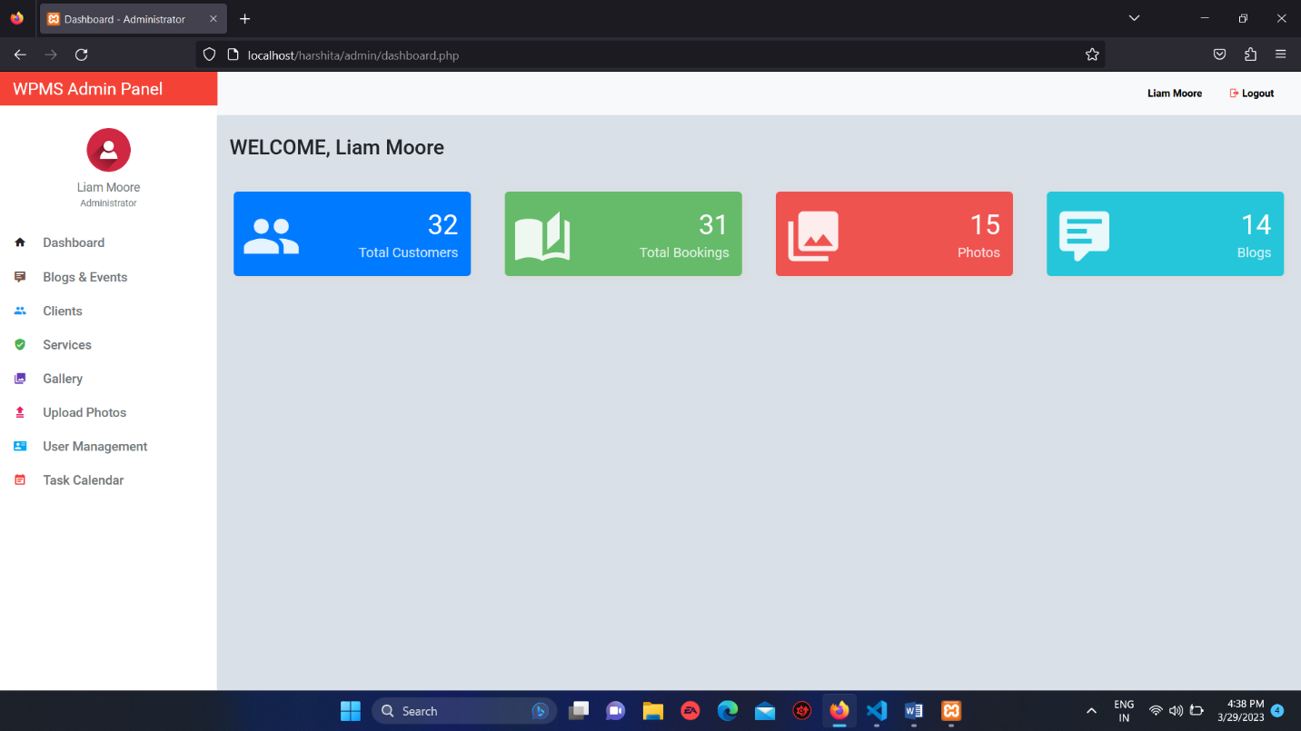

* Event manager

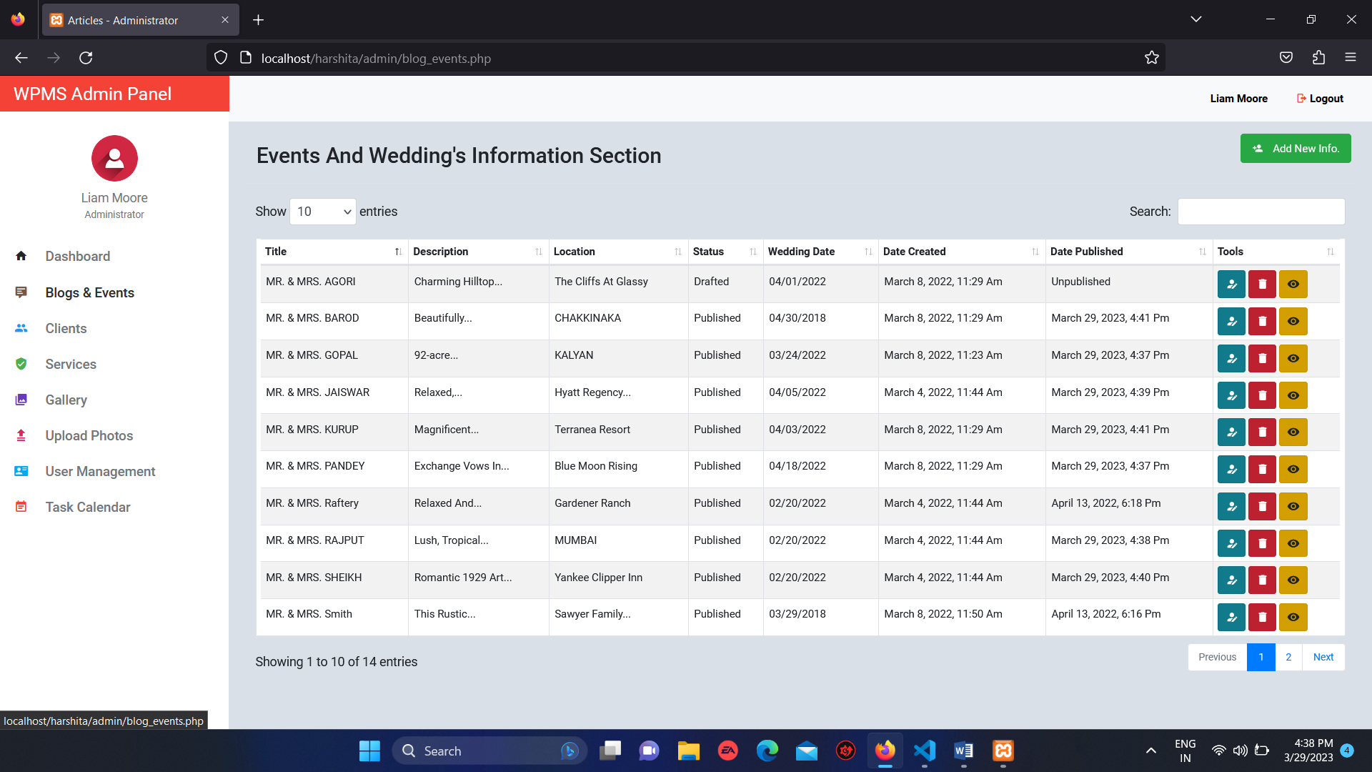

* **Client**



* Pending clients

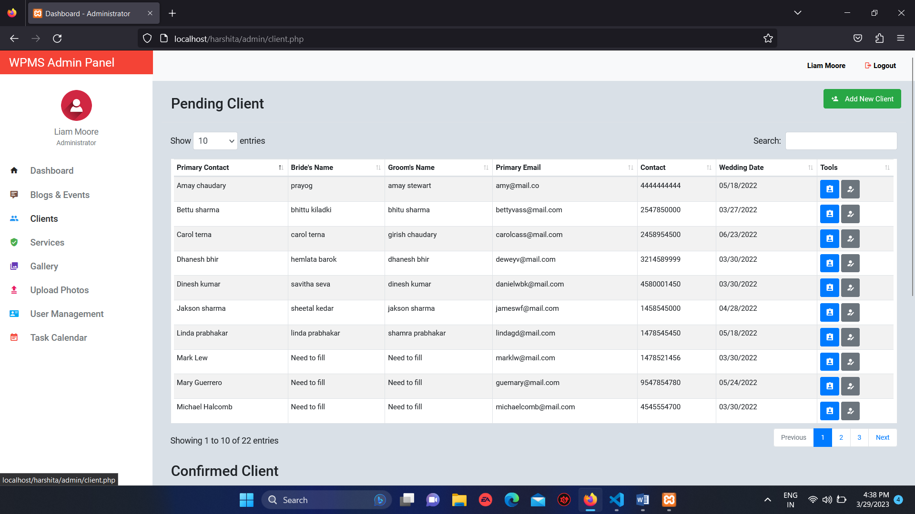

* **Service and package info/edit page**

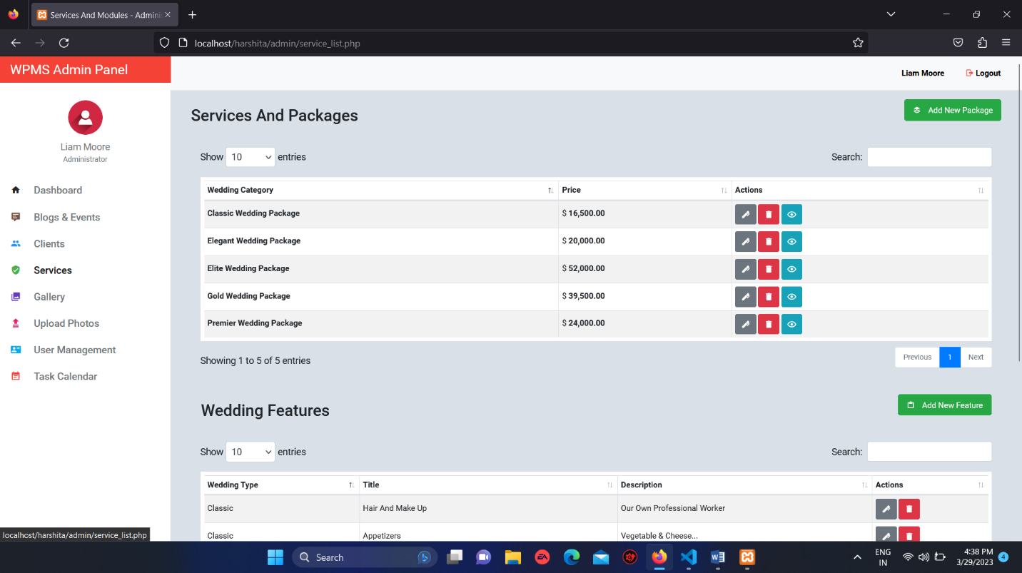

* **Upload image**

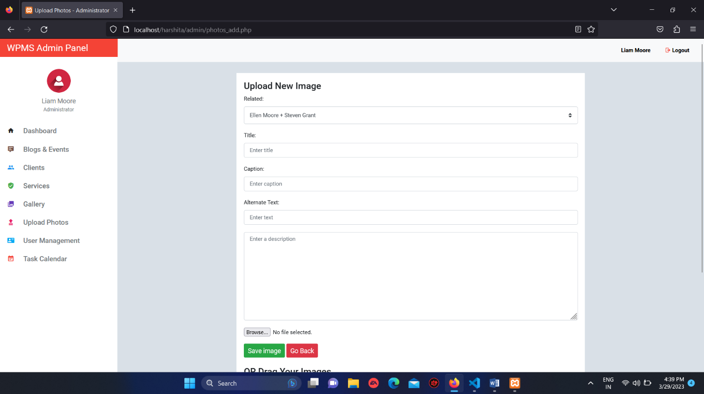

* **User management.**

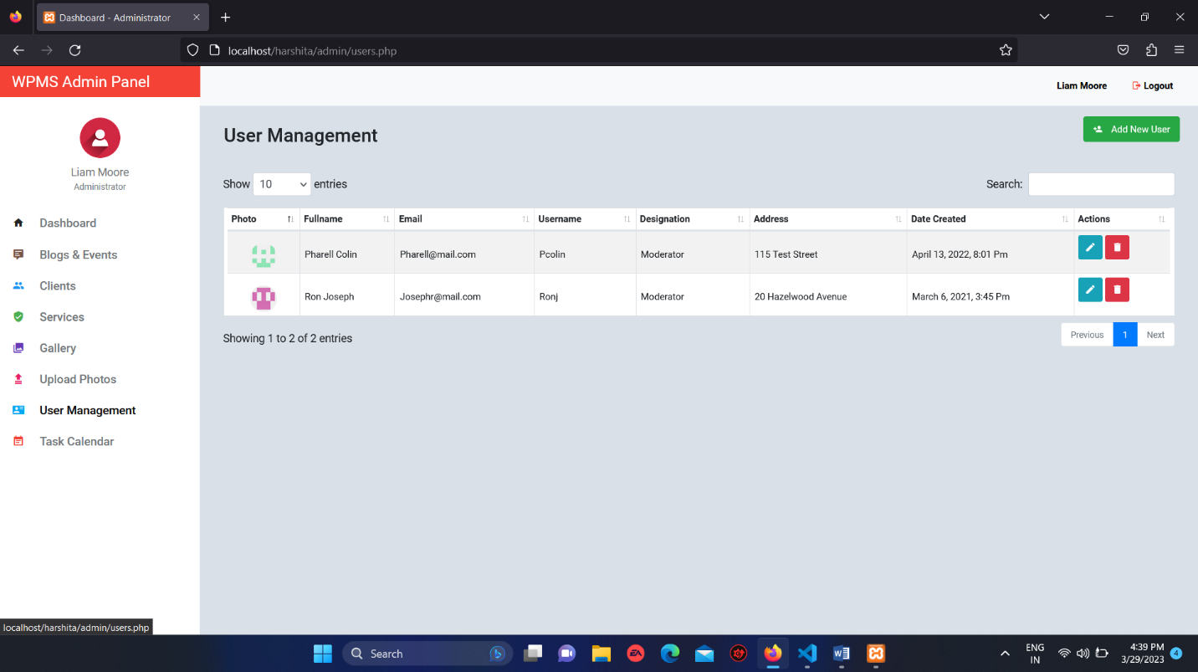

* **In-built calender.**

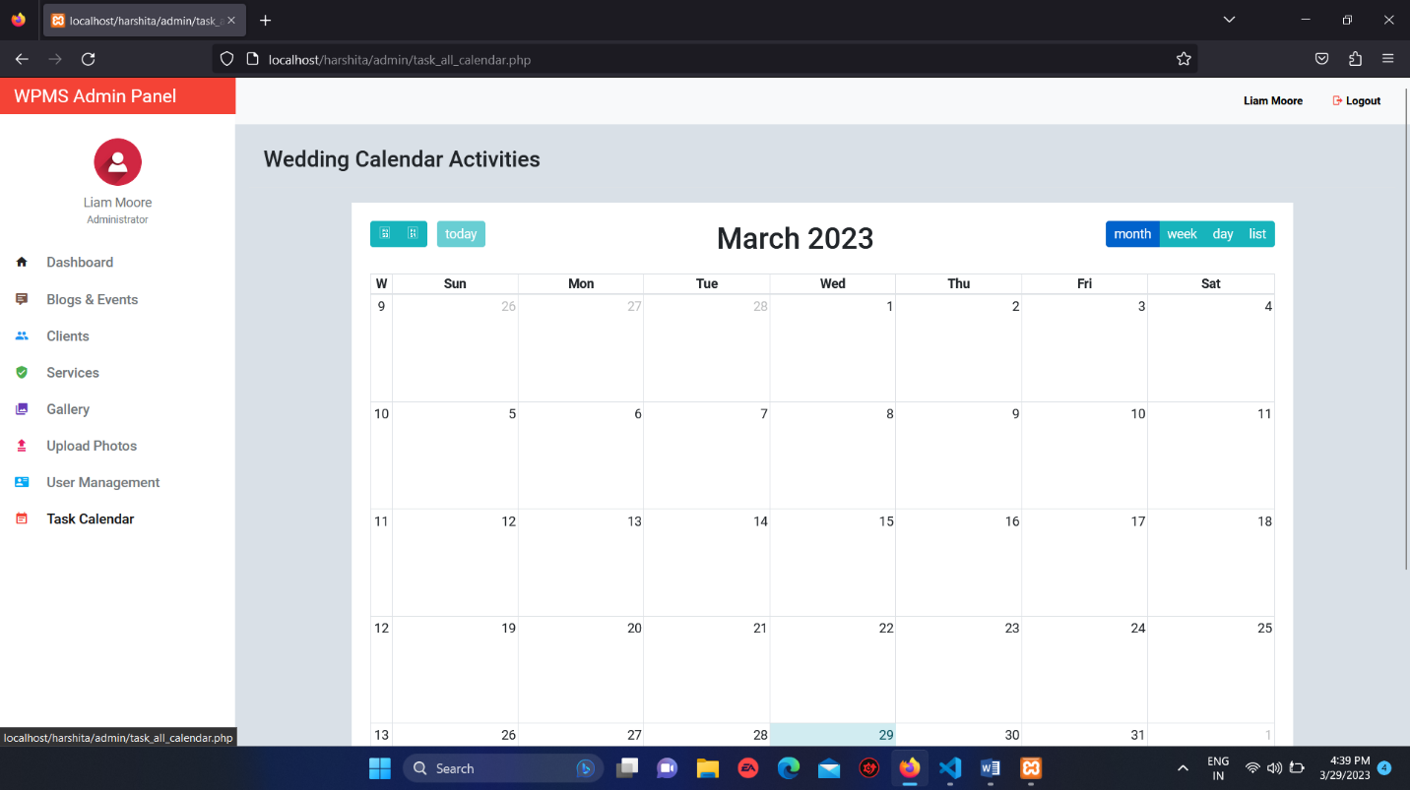

**Coding**

**INDEX PAGE (INDEX.PHP):-**

<?php include 'admin/include/init.php'; ?>

<?php

    $count = 0;

    $error = '';

    $user_firstname = $user_lastname = $user_password = $user_email = $wedding_date = '';

    $account_details = new Account_Details();

    $accounts = new Accounts();

    $booking = new Booking();

    $category = Category::find_all();

    $blogEvent = EventWedding::getEventBlogs();

    if (isset($_POST['register'])) {

        $user_firstname = clean($_POST['user_firstname']);

        $user_lastname = clean($_POST['user_lastname']);

        $user_email = clean($_POST['user_email']);

        $user_phone = clean($_POST['user_phone']);

        $wedding_date = clean($_POST['wedding_date']);

        $checkdate = $booking->check_wedding_date($wedding_date);

        if ($checkdate) {

            redirect_to("index.php");

            $session->message("

            <div class=\"alert alert-warning alert-dismissible fade show\" role=\"alert\">

              <strong><i class='mdi mdi-alert'></i></strong>  The wedding you enter is already booked. Please Try another set of date!

              <button type=\"button\" class=\"close\" data-dismiss=\"alert\" aria-label=\"Close\">

                <span aria-hidden=\"true\">&times;</span>

              </button>

            </div>");

            die();

        }

        if (empty($user_firstname) ||

            empty($user_phone) ||

            empty($user_email) ||

            empty($user_lastname) ||

            empty($wedding_date)) {

            redirect_to("index.php");

            $session->message("

            <div class=\"alert alert-warning alert-dismissible fade show\" role=\"alert\">

              <strong><i class='mdi mdi-alert'></i></strong>  Please Fill up all the fields.

              <button type=\"button\" class=\"close\" data-dismiss=\"alert\" aria-label=\"Close\">

                <span aria-hidden=\"true\">&times;</span>

              </button>

            </div>");

            die();

        }

        if (!filter_var($user_email, FILTER_VALIDATE_EMAIL)){

            redirect_to("index.php");

            $session->message("

            <div class=\"alert alert-warning alert-dismissible fade show\" role=\"alert\">

              <strong><i class='mdi mdi-alert'></i></strong>  Incorrect email format.

              <button type=\"button\" class=\"close\" data-dismiss=\"alert\" aria-label=\"Close\">

                <span aria-hidden=\"true\">&times;</span>

              </button>

            </div>");

            die();

        }

        $check_email = $accounts->email_exists($user_email);

        if ($check_email) {

            redirect_to("index.php");

            $session->message("

            <div class=\"alert alert-warning alert-dismissible fade show\" role=\"alert\">

              <strong><i class='mdi mdi-alert'></i></strong>  Email is already Exists.

              <button type=\"button\" class=\"close\" data-dismiss=\"alert\" aria-label=\"Close\">

                <span aria-hidden=\"true\">&times;</span>

              </button>

            </div>");

            die();

        } else {

            if ($error == '') {

                $count = $count + 1;

                $account_details->firstname = $user_firstname;

                $account_details->lastname = $user_lastname;

                $account_details->status = 'pending';

                $account_details->datetime_created  = date("y-m-d h:m:i");

                $account_details->phone= $user_phone;

                if ($account_details->save()) {

                    $account_details->user_id = mysqli_insert_id($db->connection);

                    if($account_details->update()) {

                        $accounts->user_id = $account_details->user_id;

                        $accounts->user_email= $user_email;

                         if($accounts->save()) {

                             $booking->user_id = $accounts->user_id;

                             $booking->user_email = $user_email;

                             $booking->wedding_date =  $wedding_date;

                             $booking->save();

                             redirect_to("thank_you.php");

                         }

                    }

                }

            }

        }

    }

?>

<!doctype html>

<html lang="en">

<head>

    <meta charset="utf-8">

    <meta name="viewport" content="width=device-width, initial-scale=1, shrink-to-fit=no">

    <title>Sara-harsh</title>

    <link href="https://fonts.googleapis.com/css?family=Open+Sans|Roboto" rel="stylesheet">

    <link rel="stylesheet" type="text/css"

          href="https://cdn.materialdesignicons.com/2.1.19/css/materialdesignicons.min.css">

    <link rel="stylesheet" href="css/bootstrap.min.css">

    <link rel="stylesheet" href="css/bootstrap-datepicker.css">

    <link rel="stylesheet" href="css/style.css">

    <style>

        .alert {

            font-size: 12px;

        }

        .error {

            background-color: #F2DEDE;

        }

        .alert.alert-danger.text-center {

            font-size: 16px;

        }

        .mdi.mdi-alert-circle.mr-3 {

            font-size: 16px;

        }

        .bgact{

                /* background: rgba(255, 255,255, 0.4); */

                background: rgb(14 14 14 / 49%);

                padding: 15px;

        }

    </style>

</head>

<body>

<?php include 'include/nav.php'; ?>

<div class="container-fluid">

    <div class="row justify-content-md-center">

        <div class="hero">

            <div class="row justify-content-md-center">

                <div class="col col-lg-3">

                </div>

                <div class="col col-lg-5" style="margin-top: 10%;">

                    <?php

                        if ($session->message()) {

                            echo $session->message();

                        }

                    ?>

                    <form class="bgact" action="<?php echo $_SERVER['PHP_SELF']; ?>" method="post">

                    <h2 class="text-center hero-lead">Wedding Planning Starts Here</h2>

                    <p class="lead text-center" style="color:white;">START BY FILLING UP THE FORM</p>

                        <div class="form-row">

                            <div class="form-group col-md-6">

                                <input type="text" class="form-control" name="user_firstname" placeholder="First Name" id="user_firstname">

                            </div>

                            <div class="form-group col-md-6">

                                <input type="text" id="user_lastname" class="form-control" name="user_lastname" placeholder="Last Name">

                            </div>

                        </div>

                        <div class="form-group">

                            <input type="text" class="form-control" name="user_email" id="user_email" placeholder="youremailaddress@mail.com">

                        </div>

                        <div class="form-group">

                            <input type="text" aria-describedby="phoneHelpBlock" class="form-control" name="user_phone" id="user_phone" placeholder="Contact Number">

                        </div>

                        <div class="form-row">

                            <div class="input-group col-md-5">

                                <input type="text" class="form-control" name="wedding_date" data-provide="datepicker" id="wedding_date"

                                       placeholder="Wedding Date">

                                <div class="input-group-append">

                                    <span class="input-group-text" style="background: white;"><i

                                                style="font-size: 20px;color:#19b5bc;" class="mdi mdi-calendar-check"

                                                id="review" aria-hidden="true"></i></span>

                                </div>

                            </div>

                        </div>

                        <div class="text-center mt-3">

                            <p style="font-size: 11px;color:white;">By clicking "Sign Up" you agree to WPMS's <a

                                        href="" title="" style="color: #b81717;font-weight: bold;">Terms of Use</a></p>

                            <button type="submit" name="register" class="btn btn-danger btn-sm text-uppercase fb"

                                    style="margin-top: -5px;">Sign Up

                            </button>

                        </div>

                    </form>

                </div>

                <div class="col col-lg-3">

                </div>

            </div>

        </div><!-- end of hero -->

    </div> <!-- end of row justify-content-md-center -->

</div><!-- end of container-fluid  -->

<div class="container-fluid custom-container">

    <div class="row">

        <div class="col-lg-12">

            <!-- <h3 class="h5 text-uppercase text-center text-muted mt-4">Wedding</h3> -->

            <hr>

            <h2 class="h2 text-uppercase text-center mb-4">Our Wedding Packages</h2>

            <?php foreach ($category as $category_row) : ?>

                <div class="pricing">

                    <ul class="list-group list-unstyled">

                        <li class="list-group-item text-center text-uppercase"><?= $category_row->wedding_type; ?></li>

                        <li><img src="admin/<?= $category_row->preview_image_picture(); ?>" class="img-fluid" alt=""></li>

                        <li class="list-group-item text-center"><b>THIS PACKAGE INCLUDES:</b></li>

                        <?php $feature = Features::find_by_feature_all($category_row->id); ?>

                            <?php foreach ($feature as $feature_item) : ?>

                                <li class="list-group-item"><?= $feature_item->title; ?></li>

                            <?php endforeach; ?>

                        <li class="list-group-item font-weight-bold">Price: $ <?= number_format($category_row->price); ?>

                         </li>

                        <li class="list-group-item font-weight-bold">

                            <a href="package_detail.php?id=<?= $category_row->id; ?>" class="btn btn-custom">View Details</a>

                        </li>

                    </ul>

                </div>

             <?php endforeach; ?>

        </div><!-- end of col-lg-12 -->

    </div><!-- end of row -->

</div><!-- end of container-fluid -->

<div class="container">

    <div class="row">

        <div class="col-lg-12">

            <h2 class="h2 text-uppercase text-center mb-3">THE LATEST INSPIRATION</h2>

            <h6 class="h6 text-uppercase text-center text-muted mb-3">Discover the best ideas, tips and articles to

                inspire

                your wedding.</h6>

            <div class="card-columns">

                <?php foreach($blogEvent as $blog_item) : ?>

                   <div class="card">

                    <img class="card-img-top" src="admin/<?= $blog_item->preview_image_picture(); ?>" alt="Card image cap">

                        <div class="card-body">

                            <a href="wedding_details.php?id=<?= $blog_item->id; ?>" class="btn-stamp">

                                <h6 class="card-title mt-0 mb-0 text-center font-weight-bold font-custom text-uppercase"><?= $blog_item->title; ?></h6>

                                <p class="card-text mt-0 mb-0 text-center color_gray"><?= $blog_item->wedding_type; ?> Wedding</p>

                                <p class="card-text mt-0 mb-0 text-center color_light text-capitalize"><i class="mdi mdi-map-marker"></i>

                                    <?= $blog_item->location; ?></p>

                            </a>

                        </div>

                    </div>

                <?php endforeach; ?>

                <a href="real-weddings.php" class="btn btn-lg btn-block btn-explore">EXPLORE MORE INSPIRATION</a>

            </div>

        </div><!-- end of col-lg-12 -->

    </div><!-- end of row -->

</div><!-- end of container -->

<div class="container-fluid" style="width: 100%;background: white;margin-top: 50px;padding-bottom: 20px;">

    <div class="row">

        <div class="col-lg-6">

            <div class="row img-control">

                <div class="col-md-1"></div>

                <div class="col-md-2">

                    <img src="DESIGN/checklist-ea253352239433deb24f2ed8ae110aac1840ff8fa5df43967027e880b5f5385b.svg"

                         alt="">

                    <div class="font-custom">CheckList</div>

                </div>

                <div class="col-md-2">

                    <img src="DESIGN/seating-chart-084bbdaabe84a638edf344224d7a92b1bc792db53c5fcf7ab16fcd5a6109ff79.svg"

                         alt="">

                    <div class="font-custom">Seating Chart</div>

                </div>

                <div class="col-md-2">

                    <img src="DESIGN/guest-list-eaaf9277c60be7449e41e2f72f358ae3c94c1b31726b894e064498a9536cac9a.svg"

                         alt="">

                    <div class="font-custom">Guess List</div>

                </div>

                <div class="col-md-2">

                    <img src="DESIGN/budget-6eca6d3898f15dd5682ce3664d8d9ff9bdd271db03857ba8a99e90b9181db46c.svg"

                         alt="">

                    <div class="font-custom">Budget</div>

                </div>

                <div class="col-md-2">

                    <img src="DESIGN/vendor-manager-102fbe8fdbab3e176a6d29bd05c6f26dcd35cfa0f55ff50b1bfd9e70c8fdcdda.svg"

                         alt="">

                    <div class="font-custom">Vendor Manager</div>

                </div>

            </div>

                <h1 class="h1 text-center mt-4">Take the Stress Out of Planning</h1>

                <p class="lead text-muted text-center ml-5" style="font-size: 14px;">Check things off your personalized to-do list all the way to your big day!</p>

        </div>

        <div class="col-lg-6">

            <div class="feature">

                <ul class="list-group rounded-0">

                    <li class="list-group-item rounded-0 d-flex justify-content-between align-items-center ">Announcement your engagement

                        <span class="badge badge-pill" style="font-size: 12px;font-weight: bold;color:#888;">OverDue <i class="mdi mdi-checkbox-blank-outline ml-3" ></i></span>

                    </li>

                    <li class="list-group-item rounded-0 d-flex justify-content-between align-items-center">Plan your engagement party

                        <span class="badge badge-pill" style="font-size: 12px;color:#888">Today <i class="mdi mdi-checkbox-blank-outline ml-3"></i></span>

                    </li>

                    <li class="list-group-item rounded-0 d-flex justify-content-between align-items-center">Schedule an engagement photo shoot

                        <span class="badge badge-pill" style="font-size: 12px;color:#888">Tomorrow <i class="mdi mdi-checkbox-blank-outline ml-3"></i></span>

                    </li>

                    <li class="list-group-item rounded-0 d-flex justify-content-between align-items-center">Set up your registry

                        <span class="badge badge-pill" style="font-size: 12px;color:#888">May 15 <i class="mdi mdi-checkbox-blank-outline ml-3"></i></span>

                    </li>

                    <li class="list-group-item rounded-0 d-flex justify-content-between align-items-center">Start your guest list

                        <span class="badge badge-pill" style="font-size: 12px;color:#888">Today <i class="mdi mdi-checkbox-blank-outline ml-3"></i></span>

                    </li>

                    <li class="list-group-item rounded-0 d-flex justify-content-between align-items-center">Decide on your wedding

                        <span class="badge badge-pill" style="font-size: 12px;color:#888">June 10 <i class="mdi mdi-checkbox-blank-outline ml-3"></i></span>

                    </li>

                    <li class="list-group-item rounded-0 d-flex justify-content-between align-items-center">Select your wedding date

                        <span class="badge badge-pill" style="font-size: 12px;color:#888">June 20 <i class="mdi mdi-checkbox-blank-outline ml-3"></i></span>

                    </li>

                </ul>

            </div>

        </div>

    </div>

</div>

<footer class="pt-3">

    <div class="row">

        <div class="col-12 col-md">

            <div class="text-center">

                <small class="d-block mb-3 text-muted">&copy; <?php echo date('Y')?> - Developed By SARA SHAIKH AND HARSHITA JAISWAR</small>

            </div>

        </div>

    </div>

</footer>

<!-- Optional JavaScript -->

<!-- jQuery first, then Popper.js, then Bootstrap JS -->

<script src="js/jquery-3.2.1.slim.min.js"></script>

<script src="js/jquery.min.js"></script>

<script src="js/popper.min.js"></script>

<script src="js/bootstrap.min.js"></script>

<script src="js/bootstrap-datepicker.min.js"></script>

<script src="js/savy.js"></script>

<script>

    $(document).ready(function () {

        $('#wedding_date').datepicker();

    <?php

        if($count == 0) {

    ?>

        $('#user_firstname').savy('load');

        $('#user_lastname').savy('load');

        $('#user_email').savy('load');

        $('#user_phone').savy('load');

        $('#wedding_date').savy('load');

    <?php } else { ?>

        $('#user_firstname').savy('destroy');

        $('#user_email').savy('destroy');

        $('#user_lastname').savy('destroy');

        $('#user_phone').savy('destroy');

        $('#wedding_date').savy('destroy');

    <?php } ?>

    });

</script>

</body>

</html>

**LOGIN.PHP:-**

<?php include_once 'admin/include/init.php';?>

<?php

 if (isset($_POST['login'])) {

     $input_email = clean($_POST['input_email']);

     $input_password= clean($_POST['input_password']);

     $logged = Accounts::login_user($input_email, $input_password);

     if($logged) {

         $session->login($logged);

         redirect_to("admin/client.php");

     } else {

         redirect_to("login.php");

         $session->message("

            <div class=\"alert alert-danger alert-dismissible fade show\" role=\"alert\">

              <strong><i class='mdi mdi-alert'></i></strong>  Invalid email and password. Please try again

              <button type=\"button\" class=\"close\" data-dismiss=\"alert\" aria-label=\"Close\">

                <span aria-hidden=\"true\">&times;</span>

              </button>

            </div>");

     }

 }

?>

<!doctype html>

<html lang="en">

<head>

    <meta charset="utf-8">

    <meta name="viewport" content="width=device-width, initial-scale=1, shrink-to-fit=no">

    <meta name="description" content="">

    <meta name="author" content="">

    <title>Login Your Account</title>

    <!-- Bootstrap core CSS -->

    <link href="css/bootstrap.min.css" rel="stylesheet">

    <!-- Custom styles for this template -->

    <link href="css/signin.css" rel="stylesheet">

</head>

<body class="text-center">

<form class="form-signin" action="login.php" method="post">

    <a href="index.php"><img class="mb-4" src="images/logo/WPMSlogo.png" width="190" ></a>

    <h3 class="h3 mb-3 font-weight-normal">Login Your Account</h3>

    <?php

        if ($session->message()) {

            echo $session->message();

        }

    ?>

    <label for="inputEmail" class="sr-only">Email address</label>

    <input type="text" id="inputEmail" name="input_email" class="form-control" placeholder="Email address" required autofocus>

    <label for="inputPassword" class="sr-only">Password</label>

    <input type="password" id="inputPassword" name="input_password" class="form-control" placeholder="Password" required>

    <div class="checkbox mb-1">

        <label>

            <input type="checkbox" value="remember-me" name="remember"> Remember me

        </label>

    </div>

    <button class="btn btn-lg btn-success btn-block" type="submit" name="login">Login</button>

    <p class="mt-5 mb-3 text-muted">&copy; 2017-2018</p>

</form>

<script src="js/jquery-3.2.1.slim.min.js"></script>

<script src="js/jquery.min.js"></script>

<script src="js/popper.min.js"></script>

<script src="js/bootstrap.min.js"></script>

<script>

    $('.your-checkbox').prop('indeterminate', true);

</script>

</body>

</html>

**GALLERY:**

<?php

    include 'admin/include/init.php';

    $gallery = Gallery::find_all();

?>

<!doctype html>

<html lang="en">

<head>

    <!-- Required meta tags -->

    <meta charset="utf-8">

    <meta name="viewport" content="width=device-width, initial-scale=1, shrink-to-fit=no">

    <title>sar-harsh</title>

    <link href="https://fonts.googleapis.com/css?family=Open+Sans|Roboto" rel="stylesheet">

    <link rel="stylesheet" type="text/css"

          href="https://cdn.materialdesignicons.com/2.1.19/css/materialdesignicons.min.css">

    <link rel="stylesheet" href="css/bootstrap.min.css">

    <link rel="stylesheet" href="css/style.css">

    <link rel="stylesheet" href="lightbox/css/lightbox.css">

    <style>

        body {

            font-family: 'Open Sans', 'Roboto', sans-serif;

            line-height: 1.5em;

            margin-bottom: 2%;

            margin-top: 2%;

            width: 100%;

            overflow-x: hidden;

            background: #f1f1f1;

        }

        .navbar-light .navbar-brand {

            color: #1a1a1a;

            font-weight: bold;

            line-height: 22px;

        }

        .navbar {

            font-weight: 700;

            padding: 12px;

            font-style: normal;

            font-size: 14px;

            text-transform: uppercase;

            color: black;

            border-bottom: 1px solid #ddd;

        }

        li.nav-item > a.nav-link {

            color: black !important;

            font-weight: bold !important;

        }

        #review {

            font-size: 16px;

            font-weight: bold;

            margin-right: 5px;

        }

        .form-inline > a.mr-2, .btn.btn-sm.my-2.my-sm-0 {

            color: black;

            font-size: 14px;

            font-weight: 700;

            margin-left: 10px;

        }

        .form-inline > a.mr-2:hover, .btn.btn-sm.my-2.my-sm-0:hover {

            color: #17b4bc;

            text-decoration: none;

        }

        a.btn.btn-sm.my-2.my-sm-0.mr-2.loginbtn {

            background: #dc3545;

            font-size: 14px;

            color: white;

            padding: 5px;

            border: 2px solid transparent;

            width: 85px;

        }

        a.btn.btn-sm.my-2.my-sm-0.mr-2.loginbtn:hover {

            background: white;

            border: 2px solid #dc3545;

            color: #dc3545;

        }

        .navbar-expand-lg .navbar-nav .nav-link {

            padding-right: .9rem;

        }

        .navbar-brand {

            margin-left: 20px;

            width: 200px;

        }

        .card {

            -webkit-border-radius:0;

            -moz-border-radius:0;

            border-radius:0;

        }

        .card img {

            -webkit-border-radius:0;

            -moz-border-radius:0;

            border-radius:0;

        }

    </style>

</head>

<body>

<?php include 'include/nav.php'; ?>

<div class="container-fluid">

    <div class="row">

        <div class="col-lg-12">

            <h4 class="text-center mb-0 mt-5">Wedding Photos</h4>

            <p class="text-center mt-0 text-muted">Photos That Capture Your Moment</p>

            <div class="card-columns">

                <?php foreach($gallery as $galleries) : ?>

                <div class="card" style="position: relative;">

                    <a href="admin/<?= $galleries->picture_path(); ?>" data-lightbox="gallery-group-4">

                        <img class="card-img-top" src="admin/<?= $galleries->picture_path(); ?>" alt="Card image cap">

                    </a>

                    <div class="card-body" style="position: absolute;bottom: 0;left:0; width: 100%;background: rgba(0,0,0, 0.5);color:white;padding: 10px 10px 0 10px;">

                        <p class="card-title text-capitalize" style="font-size:12px;"><?= empty($galleries->title) ? 'No Title' : $galleries->title; ?></p>

                    </div>

                </div><!-- end of body -->

                <?php endforeach; ?>

            </div><!-- end of card columns -->

        </div>

    </div>

<!-- Optional JavaScript -->

<!-- jQuery first, then Popper.js, then Bootstrap JS -->

<script src="js/jquery-3.2.1.slim.min.js"></script>

<script src="js/jquery.min.js"></script>

<script src="js/popper.min.js"></script>

<script src="js/bootstrap.min.js"></script>

<script src="lightbox/js/lightbox-2.6.min.js"></script>

</body>

</html>

**CONTACT.PHP:**

<!doctype html>

<html lang="en">

<head>

    <!-- Required meta tags -->

    <meta charset="utf-8">

    <meta name="viewport" content="width=device-width, initial-scale=1, shrink-to-fit=no">

    <title>Sar-harsh</title>

    <link href="https://fonts.googleapis.com/css?family=Open+Sans|Roboto" rel="stylesheet">

    <link rel="stylesheet" type="text/css"

          href="https://cdn.materialdesignicons.com/2.1.19/css/materialdesignicons.min.css">

    <link rel="stylesheet" href="css/bootstrap.min.css">

    <link rel="stylesheet" href="css/datepicker.css">

    <link rel="stylesheet" href="css/style.css">

    <link rel="stylesheet" href="css/carousel.css">

    <style>

        body {

            font-family: 'Open Sans', 'Roboto', sans-serif;

            line-height: 1.5em;

            margin-bottom: 2%;

            margin-top: 3%;

            width: 100%;

            overflow-x: hidden;

            background: #f1f1f1;

        }

        .navbar-light .navbar-brand {

            color: #1a1a1a;

            font-weight: bold;

            line-height: 22px;

        }

        .navbar {

            font-weight: 700;

            padding: 12px;

            font-style: normal;

            font-size: 14px;

            text-transform: uppercase;

            color: black;

            border-bottom: 1px solid #ddd;

        }

        li.nav-item > a.nav-link {

            color: black !important;

            font-weight: bold !important;

        }

        #review {

            font-size: 16px;

            font-weight: bold;

            margin-right: 5px;

        }

        .form-inline > a.mr-2, .btn.btn-sm.my-2.my-sm-0 {

            color: black;

            font-size: 14px;

            font-weight: 700;

            margin-left: 10px;

        }

        .form-inline > a.mr-2:hover, .btn.btn-sm.my-2.my-sm-0:hover {

            color: #17b4bc;

            text-decoration: none;

        }

        a.btn.btn-sm.my-2.my-sm-0.mr-2.loginbtn {

            background: #dc3545;

            font-size: 14px;

            color: white;

            padding: 5px;

            border: 2px solid transparent;

            width: 85px;

        }

        a.btn.btn-sm.my-2.my-sm-0.mr-2.loginbtn:hover {

            background: white;

            border: 2px solid #dc3545;

            color: #dc3545;

        }

        .navbar-expand-lg .navbar-nav .nav-link {

            padding-right: .9rem;

        }

        .navbar-brand {

            margin-left: 20px;

            width: 200px;

        }

        .form-control {

            font-size: 12px;

            border-radius: 0;

            margin-top: 0;

        }

    </style>

</head>

<body>

<?php include "include/nav.php"; ?>

<div class="container">

    <div class="row">

        <div class="col-lg-12">

            <h3 class="text-center mb-3">CONTACT US</h3>

            <div class="bg-white p-4">

                <div class="contact-information">

                    <h5>LANDMARKET</h5>

                    <div class="row">

                        <div class="col-md-8">

                            <table class="table table-sm" style="font-size: 12px;">

                                <tr>

                                    <td>Big Day Planners</td>

                                    <td><i class="mdi mdi-deskphone mr-3"></i> 999 (999) 999</td>

                                </tr>

                                <tr>

                                    <td>6th Floor, Valencia City</td>

                                    <td><i class="mdi mdi-phone mr-3"></i> +91 99896722351</td>

                                </tr>

                                <tr>

                                    <td>Street P-4 Poblacion 88825</td>

                                    <td><i class="mdi mdi-email mr-3"></i> contactemail@gmail.com</td>

                                </tr>

                            </table>

                        </div>

                        <div class="col-md-4">

                            <div class="text-center mt-3">

                                <i class="mdi mdi-map-marker" style="font-size: 110px;color: #22ADB5;"></i>

                            </div>

                        </div>

                    </div>

                </div>

            </div>

            <div class="bg-white mt-3 pt-1 pl-4 pb-3">

                <div class="row mt-3">

                    <div class="col-md-12">

                        <form action="" method="post" style="font-size: 12px;">

                            <div class="row">

                                <div class="col-md-6">

                                    <div class="form-row">

                                        <div class="form-group col-md-12 mb-1">

                                            <label for="contact_person">Name</label>

                                            <input type="email" class="form-control" id="contact_person" placeholder="Enter contact person">

                                        </div>

                                        <div class="form-group col-md-12 mb-1">

                                            <label for="contact_email">Email</label>

                                            <input type="password" class="form-control" id="contact_email" placeholder="Enter email">

                                        </div>

                                        <div class="form-group col-md-12 mb-1">

                                            <label for="contact_phone">Phone</label>

                                            <input type="text" class="form-control" id="contact_phone" placeholder="Enter mobile phone">

                                        </div>

                                        <div class="form-group col-md-12 mb-1">

                                            <label for="contact_message">Message</label>

                                            <textarea type="text" class="form-control"

                                                      style="resize: none;" rows="8"

                                                      id="contact_message" placeholder="Enter message"></textarea>

                                        </div>

                                    </div>

                                </div>

                                <div class="col-md-6 pr-2">

                                    <iframe src="https://www.google.com/maps/embed?pb=!1m18!1m12!1m3!1d3951.804581750715!2d125.08993251421961!3d7.915471407613357!2m3!1f0!2f0!3f0!3m2!1i1024!2i768!4f13.1!3m3!1m2!1s0x32ff1a2d27bfc2c5%3A0x49f6694edf036a5a!2sAMA+Computer+Learning+Center!5e0!3m2!1sen!2sph!4v1518944564341" width="95%" height="395" frameborder="0" style="border:0" allowfullscreen></iframe>

                                </div>

                            </div>

                            <button type="submit" class="btn btn-primary btn-sm rounded-0" style="font-size: 12px;margin-top: 10px;background: #22adb5;border: 0;">Send Message</button>

                        </form>

                    </div>

                </div>

            </div>

        </div>

    </div>

</div>

<!-- MODAL LOGIN SECTION-->

<div class="modal fade" id="loginModal" tabindex="-1" role="dialog" aria-labelledby="loginModal" aria-hidden="true">

    <div class="modal-dialog" role="document">

        <div class="modal-content">

            <div class="modal-header">

                <h5 class="modal-title" id="loginModal"><img src="images/logo/MOMMYAMBOL.png" alt=""></h5>

                <button type="button" class="close" data-dismiss="modal" aria-label="Close">

                    <span aria-hidden="true">&times;</span>

                </button>

            </div>

            <div class="modal-body">

                <form action="register.php" method="post">

                    <div class="form-group row">

                        <label for="inputEmail" class="col-sm-2 col-form-label">Email:</label>

                        <div class="col-sm-10">

                            <input type="text" class="form-control" id="inputEmail" name="email"

                                   placeholder="Enter email">

                        </div>

                    </div>

                    <div class="form-group row">

                        <label for="inputPassword" class="col-sm-2 col-form-label">Password:</label>

                        <div class="col-sm-10">

                            <input type="password" class="form-control" id="inputPassword" placeholder="Enter password">

                        </div>

                    </div>

                    <div class="form-group row">

                        <label for="login" class="col-sm-2 col-form-label"></label>

                        <div class="col-sm-10">

                            <button type="button" class="btn btn-primary mr-2 custom-btn" style="font-size: 14px;">

                                Login

                            </button>

                            <a href="" style="color: #22adb5;">Forgot your password?</a>

                            <br/>

                            <div class="mt-2">Not a member yet? <a href="" style="color: #22adb5;">Join Now</a></div

                        </div>

                    </div>

                </form>

            </div>

        </div>

    </div>

</div>

<!-- Optional JavaScript -->

<!-- jQuery first, then Popper.js, then Bootstrap JS -->

<script src="js/jquery-3.2.1.slim.min.js"></script>

<script src="js/jquery.min.js"></script>

<script src="js/popper.min.js"></script>

<script src="js/bootstrap.min.js"></script>

</body>

</html>

**LOGIN1.PHP**

<?php include_once 'admin/include/init.php';?>

<?php

if (isset($_POST['login'])) {

    $input_email = $_POST['email'];

    $input_password = $_POST['password'];

    $logged = Accounts::login_user($input_email, $input_password);

    echo $logged;

}

?>

**: CONCLUSION:**

<?php include 'admin/include/init.php'; ?>

<?php

    $id = $_GET['id'];

    $category = Category::find_by_id($id);

    $count = 0;

    $error =$user_firstname = $user_lastname = $user_password = $user_email = $wedding_date = '';

    $account_details = new Account_Details();

    $accounts = new Accounts();

    $booking = new Booking();

    if (isset($_POST['register'])) {

        $user_firstname = clean($_POST['user_firstname']);

        $user_lastname  = clean($_POST['user_lastname']);

        $user_email     = clean($_POST['user_email']);

        $user_password  = clean($_POST['user_password']);

        $wedding_date   = clean($_POST['wedding_date']);

        $user_phone     = clean($_POST['user_phone']);

        $bid = clean($_POST['booking_id']);

        $checkdate = $booking->check_wedding_date($wedding_date);

        if ($checkdate) {

            redirect_to("package_detail.php?id=$bid");

            $session->message("

            <div class=\"alert alert-warning alert-dismissible fade show\" role=\"alert\">

              <strong><i class='mdi mdi-alert'></i></strong>  The wedding you enter is already booked. Please Try another set of date!

              <button type=\"button\" class=\"close\" data-dismiss=\"alert\" aria-label=\"Close\">

                <span aria-hidden=\"true\">&times;</span>

              </button>

            </div>");

            die();

        }

        // if (empty($user_firstname) ||

        //     empty($user_password) ||

        //     empty($user_email) ||

        //     empty($user_lastname) ||

        //     empty($wedding_date)) {

        //     redirect_to("package_detail.php?id=$bid");

        //     $session->message("

        //     <div class=\"alert alert-warning alert-dismissible fade show\" role=\"alert\">

        //       <strong><i class='mdi mdi-alert'></i></strong>  Please Fill up all the fields.

        //       <button type=\"button\" class=\"close\" data-dismiss=\"alert\" aria-label=\"Close\">

        //         <span aria-hidden=\"true\">&times;</span>

        //       </button>

        //     </div>");

        //     die();

        // } else {

        //     if ($error == '') {

        //         $count = $count + 1;

        //         $account_details->firstname = $user_firstname;

        //         $account_details->lastname = $user_lastname;

        //         $account_details->status = 'pending';

        //         $account_details->phone = $user_phone;

        //         $account_details->datetime_created  = date("y-m-d h:m:i");

        //         if ($account_details->save()) {

        //             $account_details->user_id = mysqli_insert_id($db->connection);

        //             if($account_details->update()) {

        //                 $accounts->user_id = $account_details->user_id;

        //                 $accounts->user_email= $user_email;

        //                  if($accounts->save()) {

        //                      $booking->user_id = $accounts->user_id;

        //                      $booking->wedding_type = $bid;

        //                      $booking->user_email = $user_email;

        //                      $booking->wedding_date =  $wedding_date;

        //                      $booking->save();

        //                      redirect_to("package_detail.php?id=".$bid);

        //                  }

        //             }

        //         }

        //     }

        // }

        if (!filter_var($user_email, FILTER_VALIDATE_EMAIL)){

            redirect_to("package_detail.php?id=$bid");

            $session->message("

            <div class=\"alert alert-warning alert-dismissible fade show\" role=\"alert\">

              <strong><i class='mdi mdi-alert'></i></strong>  Incorrect email format.

              <button type=\"button\" class=\"close\" data-dismiss=\"alert\" aria-label=\"Close\">

                <span aria-hidden=\"true\">&times;</span>

              </button>

            </div>");

            die();

        }

        $check_email = $accounts->email_exists($user_email);

        if ($check_email) {

            redirect_to("package_detail.php?id=$bid");

            $session->message("

            <div class=\"alert alert-warning alert-dismissible fade show\" role=\"alert\">

              <strong><i class='mdi mdi-alert'></i></strong>  Email is already Exists.

              <button type=\"button\" class=\"close\" data-dismiss=\"alert\" aria-label=\"Close\">

                <span aria-hidden=\"true\">&times;</span>

              </button>

            </div>");

            die();

        } else {

            if ($error == '') {

                $count = $count + 1;

                $account_details->firstname = $user_firstname;

                $account_details->lastname = $user_lastname;

                $account_details->status = 'pending';

                $account_details->phone = $user_phone;

                $account_details->datetime_created  = date("y-m-d h:m:i");

                if ($account_details->save()) {

                    $account_details->user_id = mysqli_insert_id($db->connection);

                    if($account_details->update()) {

                        $accounts->user_id = $account_details->user_id;

                        $accounts->user_email= $user_email;

                         if($accounts->save()) {

                             $booking->user_id = $accounts->user_id;

                             $booking->wedding_type = $bid;

                             $booking->user_email = $user_email;

                             $booking->wedding_date =  $wedding_date;

                             $booking->save();

                             redirect_to("package_detail.php?id=".$bid);

                         }

                    }

                }

            }

        }

    }

?>

<!doctype html>

<html lang="en">

<head>

    <!-- Required meta tags -->

    <meta charset="utf-8">

    <meta name="viewport" content="width=device-width, initial-scale=1, shrink-to-fit=no">

    <title>Wedding Planner</title>

    <link href="https://fonts.googleapis.com/css?family=Open+Sans|Roboto" rel="stylesheet">

    <link rel="stylesheet" type="text/css"

          href="https://cdn.materialdesignicons.com/2.1.19/css/materialdesignicons.min.css">

    <link rel="stylesheet" href="css/bootstrap.min.css">

    <link rel="stylesheet" href="css/style.css">

    <link rel="stylesheet" href="css/bootstrap-datepicker.css">

    <style>

        body {

            margin-top: 6%;

        }

        .navbar-light .navbar-brand {

            color: #1a1a1a;

            font-weight: bold;

            line-height: 22px;

        }

        .navbar {

            font-weight: 700;

            padding: 12px;

            font-style: normal;

            font-size: 14px;

            text-transform: uppercase;

            color: black;

            border-bottom: 1px solid #ddd;

        }

        li.nav-item > a.nav-link {

            color: black !important;

            font-weight: bold !important;

        }

        #review {

            font-size: 16px;

            font-weight: bold;

            margin-right: 5px;

        }

        .navbar-expand-lg .navbar-nav .nav-link {

            padding-right: .9rem;

        }

        .navbar-brand {

            margin-left: 20px;

            width: 200px;

        }

        img.img-fluid.img-custom {

            width: 344px;

            height:230px;

        }

        .btn.btn-sm.btn-light.active:hover {

            background: white;

        }

        .list-group-item:first-child {

            border-top-left-radius: 0rem;

            border-top-right-radius: 0rem;

        }

        .list-group-item.active{

            border-color: #00125100;

        }

    </style>

</head>

<body>

<?php include 'include/nav.php'; ?>

<div class="container">

     <div class="row">

        <div class="col-md-8 p-0" style="margin-bottom: 20px;"> <!-- border:1px solid rgba(0,0,0,.125) -->

            <div class="float-left bg-white">

                <h5 class="h5 text-uppercase mb-5 pt-3 pl-3 pr-3">

                    <span class="float-left text-capitalize"><?= $category->wedding_type; ?> Package Wedding</span>

                    <span class="float-right text-capitalize">Price: $ <?= number_format($category->price,2); ?></span>

                </h5>

                <img src="admin/<?= $category->preview_image_picture(); ?>" style="width: 700px;" alt="">

                <ul class="list-group">

                        <li class="list-group-item list-group-item-action bg-danger flex-column align-items-start active">

                            <div class="d-flex w-100 justify-content-between">

                                <h5 class="mb-1 pt-2 pb-2">FUNCTIONS AND SERVICES</h5>

                            </div>

                        </li>

                    <?php $feature = Features::find_by_feature_no_limit($category->id); ?>

                        <?php foreach ($feature as $feature_item) : ?>

                            <li class="list-group-item list-group-item-action flex-column align-items-start">

                                <div class="d-flex w-100 justify-content-between">

                                    <h5 class="mb-1"><i class="mdi mdi-check mr-3"></i><?= $feature_item->title; ?></h5>

                                </div>

                                <p class="mb-1 ml-3 text-capitalize"><?= $feature_item->description; ?></p>

                            </li>

                        <?php endforeach; ?>

                    </ul>

                </div>

            </div><!-- end of col-md-8 p-0 pl-3 -->

            <div class="col-md-4" style="margin-bottom: 20px;">

                    <form action="<?php echo $_SERVER['PHP_SELF']; ?>" method="post" style="background: white;padding: 20px;">

                        <?php

                            if ($session->message()) {

                                echo $session->message();

                            }

                        ?>

                         <h5 class="h5 text-center mb-3 m-0">Wedding Planning Starts Here</h5>

                        <div class="form-group">

                            <input type="text" class="form-control" name="user_firstname" placeholder="First name" id="user_firstname">

                        </div>

                        <div class="form-group">

                            <input type="text" id="user_lastname" class="form-control" name="user_lastname" placeholder="Last name">

                        </div>

                        <div class="form-group">

                            <input type="number" id="user_phone" class="form-control" name="user_phone" placeholder="Phone number">

                        </div>

                        <div class="form-group">

                            <input type="email" class="form-control" name="user_email" id="user_email" placeholder="youremail@gmail.com">

                        </div>

                        <div class="form-row">

                            <div class="input-group col-md-12">

                                <input type="text" class="form-control" name="wedding_date" data-provide="datepicker" id="wedding_date"

                                       placeholder="Wedding Date">

                                <div class="input-group-append">

                                    <span class="input-group-text" style="background: white;"><i

                                                style="font-size: 20px;color:#19b5bc;" class="mdi mdi-calendar-check"

                                                id="wedding_date" aria-hidden="true"></i></span>

                                </div>

                            </div>

                        </div>

                        <div class="text-center mt-3">

                            <input type="hidden" name="booking_id" value="<?= $_GET['id']; ?>">

                            <button type="submit" name="register" class="btn btn-success btn-sm text-uppercase font-weight-bold"

                                    style="margin-top: -5px;">Book Now

                            </button>

                        </div>

                    </form>

            </div>

        </div>

</div><!-- end of container -->

<!-- Optional JavaScript -->

<!-- jQuery first, then Popper.js, then Bootstrap JS -->

<script src="js/jquery-3.2.1.slim.min.js"></script>

<script src="js/jquery.min.js"></script>

<script src="js/popper.min.js"></script>

<script src="js/bootstrap.min.js"></script>

<script src="js/bootstrap-datepicker.min.js"></script>

<script>

    $(document).ready(function () {

        $('#wedding_date').datepicker();

    });

</script>

</body>

</html>

**PRICING.PHP:**

<?php include 'admin/include/init.php'; ?>

<?php

$category = Category::find_all();

?>

<!doctype html>

<html lang="en">

<head>

    <!-- Required meta tags -->

    <meta charset="utf-8">

    <meta name="viewport" content="width=device-width, initial-scale=1, shrink-to-fit=no">

    <title>Sar-harsh</title>

    <link href="https://fonts.googleapis.com/css?family=Open+Sans|Roboto" rel="stylesheet">

    <link rel="stylesheet" type="text/css"

          href="https://cdn.materialdesignicons.com/2.1.19/css/materialdesignicons.min.css">

    <link rel="stylesheet" href="css/bootstrap.min.css">

    <link rel="stylesheet" href="css/style.css">

    <style>

        body {

            margin-top: 6%;

        }

        .navbar-light .navbar-brand {

            color: #1a1a1a;

            font-weight: bold;

            line-height: 22px;

        }

        .navbar {

            font-weight: 700;

            padding: 12px;

            font-style: normal;

            font-size: 14px;

            text-transform: uppercase;

            color: black;

            border-bottom: 1px solid #ddd;

        }

        li.nav-item > a.nav-link {

            color: black !important;

            font-weight: bold !important;

        }

        #review {

            font-size: 16px;

            font-weight: bold;

            margin-right: 5px;

        }

        .navbar-expand-lg .navbar-nav .nav-link {

            padding-right: .9rem;

        }

        .navbar-brand {

            margin-left: 20px;

            width: 200px;

        }

        img.img-fluid.img-custom {

            width: 344px;

            height:230px;

        }

        .btn.btn-sm.btn-light.active:hover {

            background: white;

        }

        .list-group-item:first-child {

            border-top-left-radius: 0rem;

            border-top-right-radius: 0rem;

        }

        .list-group-item:last-child {

            border-bottom-right-radius: 0;

            border-bottom-left-radius: 0;

        }

        .list-group-item.active{

            border-color: #00125100;

        }

    </style>

</head>

<body>

<?php include 'include/nav.php'; ?>

<div class="container" style="width: 70%;">

    <div class="row mb-3">

        <div class="col-lg-12">

            <h3 class="h5 text-uppercase text-center text-muted">Wedding</h3>

            <h2 class="h2 text-uppercase text-center mb-0">Select Package</h2>

        </div>

    </div>

    <?php foreach ($category as $category_row) : ?>

     <div class="row">

        <div class="col-md-12 p-0" style="margin-bottom: 20px;"> <!-- border:1px solid rgba(0,0,0,.125) -->

            <div class="float-left">

                <img src="admin/<?= $category_row->preview_image_picture(); ?>" style="width: 500px;" alt="">

            </div>

            <div class="float-left" style="width: 47%;">

                <ul class="list-group">

                    <li class="list-group-item bg-danger active" style="padding-top: 12px;"><h6 class="h6 text-center"><?= $category_row->wedding_type; ?> Package Wedding - Price: $ <?= number_format($category_row->price,2); ?></h6></li>

                    <li class="list-group-item  list-group-item-light "><b>THIS PACKAGE INCLUDES:</b></li>

                    <?php $feature = Features::find_by_feature_all($category_row->id); ?>

                    <?php foreach ($feature as $feature_item) : ?>

                        <li class="list-group-item"><?= $feature_item->title; ?></li>

                    <?php endforeach; ?>

                </ul>

                 <div class="float-right">

                <a href="package_detail.php?id=<?= $category_row->id; ?>" class="btn btn-sm btn-success active" style="border-radius: 3px;margin-top: 9px;">Book Now</a>

                <a href="package_detail.php?id=<?= $category_row->id; ?>" class="btn btn-sm btn-primary active" style="border-radius: 3px;margin-top: 9px;">More Detail</a>

            </div>

            </div>

            </div><!-- end of col-md-8 p-0 pl-3 -->

        </div>

        <?php endforeach; ?>

</div><!-- end of container -->

<!-- Optional JavaScript -->

<!-- jQuery first, then Popper.js, then Bootstrap JS -->

<script src="js/jquery-3.2.1.slim.min.js"></script>

<script src="js/jquery.min.js"></script>

<script src="js/popper.min.js"></script>

<script src="js/bootstrap.min.js"></script>

</body>

</html>

**REAL-WEDDING_INFO;**

<?php include 'admin/include/init.php'; ?>

<?php

$category = Category::find_all();

?>

<!doctype html>

<html lang="en">

<head>

    <!-- Required meta tags -->

    <meta charset="utf-8">

    <meta name="viewport" content="width=device-width, initial-scale=1, shrink-to-fit=no">

    <title>Sar-harsh</title>

    <link href="https://fonts.googleapis.com/css?family=Open+Sans|Roboto" rel="stylesheet">

    <link rel="stylesheet" type="text/css"

          href="https://cdn.materialdesignicons.com/2.1.19/css/materialdesignicons.min.css">

    <link rel="stylesheet" href="css/bootstrap.min.css">

    <link rel="stylesheet" href="css/style.css">

    <style>

        body {

            margin-top: 6%;

        }

        .navbar-light .navbar-brand {

            color: #1a1a1a;

            font-weight: bold;

            line-height: 22px;

        }

        .navbar {

            font-weight: 700;

            padding: 12px;

            font-style: normal;

            font-size: 14px;

            text-transform: uppercase;

            color: black;

            border-bottom: 1px solid #ddd;

        }

        li.nav-item > a.nav-link {

            color: black !important;

            font-weight: bold !important;

        }

        #review {

            font-size: 16px;

            font-weight: bold;

            margin-right: 5px;

        }

        .navbar-expand-lg .navbar-nav .nav-link {

            padding-right: .9rem;

        }

        .navbar-brand {

            margin-left: 20px;

            width: 200px;

        }

        img.img-fluid.img-custom {

            width: 344px;

            height:230px;

        }

        .btn.btn-sm.btn-light.active:hover {

            background: white;

        }

        .list-group-item:first-child {

            border-top-left-radius: 0rem;

            border-top-right-radius: 0rem;

        }

        .list-group-item:last-child {

            border-bottom-right-radius: 0;

            border-bottom-left-radius: 0;

        }

        .list-group-item.active{

            border-color: #00125100;

        }

    </style>

</head>

<body>

<?php include 'include/nav.php'; ?>

<div class="container" style="width: 70%;">

    <div class="row mb-3">

        <div class="col-lg-12">

            <h3 class="h5 text-uppercase text-center text-muted">Wedding</h3>

            <h2 class="h2 text-uppercase text-center mb-0">Select Package</h2>

        </div>

    </div>

    <?php foreach ($category as $category_row) : ?>

     <div class="row">

        <div class="col-md-12 p-0" style="margin-bottom: 20px;"> <!-- border:1px solid rgba(0,0,0,.125) -->

            <div class="float-left">

                <img src="admin/<?= $category_row->preview_image_picture(); ?>" style="width: 500px;" alt="">

            </div>

            <div class="float-left" style="width: 47%;">

                <ul class="list-group">

                    <li class="list-group-item bg-danger active" style="padding-top: 12px;"><h6 class="h6 text-center"><?= $category_row->wedding_type; ?> Package Wedding - Price: $ <?= number_format($category_row->price,2); ?></h6></li>

                    <li class="list-group-item  list-group-item-light "><b>THIS PACKAGE INCLUDES:</b></li>

                    <?php $feature = Features::find_by_feature_all($category_row->id); ?>

                    <?php foreach ($feature as $feature_item) : ?>

                        <li class="list-group-item"><?= $feature_item->title; ?></li>

                    <?php endforeach; ?>

                </ul>

                 <div class="float-right">

                <a href="package_detail.php?id=<?= $category_row->id; ?>" class="btn btn-sm btn-success active" style="border-radius: 3px;margin-top: 9px;">Book Now</a>

                <a href="package_detail.php?id=<?= $category_row->id; ?>" class="btn btn-sm btn-primary active" style="border-radius: 3px;margin-top: 9px;">More Detail</a>

            </div>

            </div>

            </div><!-- end of col-md-8 p-0 pl-3 -->

        </div>

        <?php endforeach; ?>

</div><!-- end of container -->

<!-- Optional JavaScript -->

<!-- jQuery first, then Popper.js, then Bootstrap JS -->

<script src="js/jquery-3.2.1.slim.min.js"></script>

<script src="js/jquery.min.js"></script>

<script src="js/popper.min.js"></script>

<script src="js/bootstrap.min.js"></script>

</body>

</html>

**REAL_WEDDING.PHP:**

<?php include 'admin/include/init.php'; ?>

<?php

    $blogEvent = EventWedding::getEventBlogs();

 ?>

<!doctype html>

<html lang="en">

<head>

    <!-- Required meta tags -->

    <meta charset="utf-8">

    <meta name="viewport" content="width=device-width, initial-scale=1, shrink-to-fit=no">

    <title>Inspiration Couples</title>

    <link href="https://fonts.googleapis.com/css?family=Open+Sans|Roboto" rel="stylesheet">

    <link rel="stylesheet" type="text/css" href="https://cdn.materialdesignicons.com/2.1.19/css/materialdesignicons.min.css">

    <link rel="stylesheet" href="css/bootstrap.min.css">

    <link rel="stylesheet" href="css/datepicker.css">

    <link rel="stylesheet" href="css/style.css">

    <style>

        body {

            background: #fff;

            margin-top:6%;

        }

       /* img.card-img-top {

            width: 100%;

            height: 350px;

            -webkit-border-radius:0;

            -moz-border-radius:0;

            border-radius:0;

        }

        .card-body {

            background: #EDEDED;

            padding: 1rem;

        }

        .font-custom {

            font-size: 16px;

        }

        .color_gray {

            color: #555;

        }*/

       /* .color_light {

            color: #999;

            font-weight: 600;

        }

        h6.font-custom {

            color: #555;

        }

        a.btn-stamp:hover {

            text-decoration: none;

        }

        img.image-stock {

            width: 86px;margin-left: 6px;margin-bottom: 6px;

        }

        .card-style {

            background: none;border:0;

        }*/

    </style>

</head>

<body>

<?php

include "include/nav.php";

?>

<div class="container">

    <div class="row">

        <div class="col-lg-12">

            <h4 class="h2 text-center mb-0">THE LATEST INSPIRATION</h4>

            <p class="text-muted text-center">Discover the best ideas, tips and articles to inspire your wedding.</p>

        </div>

           <div class="card-columns">

            <?php foreach($blogEvent as $blog_item) : ?>

               <div class="card">

                <img class="card-img-top" src="admin/<?= $blog_item->preview_image_picture(); ?>" alt="Card image cap">

                <div class="card-body">

                    <a href="wedding_details.php?id=<?= $blog_item->id; ?>" class="btn-stamp">

                        <h6 class="card-title mt-0 mb-0 text-center font-weight-bold font-custom text-uppercase"><?= $blog_item->title; ?></h6>

                        <p class="card-text mt-0 mb-0 text-center color_gray"><?= $blog_item->wedding_type; ?> Wedding</p>

                        <p class="card-text mt-0 mb-0 text-center color_light text-capitalize"><i class="mdi mdi-map-marker"></i>

                            <?= $blog_item->location; ?></p>

                    </a>

                </div>

            </div>

            <?php endforeach; ?>

            <!-- <a href="real-weddings.php" class="btn btn-lg btn-block btn-explore">EXPLORE MORE INSPIRATION</a> -->

        </div>

    </div>

</div>

<!-- Optional JavaScript -->

<!-- jQuery first, then Popper.js, then Bootstrap JS -->

<script src="js/jquery-3.2.1.slim.min.js"></script>

<script src="js/jquery.min.js"></script>

<script src="js/popper.min.js"></script>

<script src="js/bootstrap.min.js"></script>

</body>

</html>

**SIGN_UP.PHP:**

<?php include 'admin/include/init.php'; ?>

<?php

$count = 0;

$error = '';

$user_firstname = $user_lastname = $user_password = $user_email = $wedding_date = '';

$account_details = new Account_Details();

$accounts = new Accounts();

$booking = new Booking();

$category = Category::find_all();

$blogEvent = EventWedding::getEventBlogs();

if (isset($_POST['register'])) {

    $user_firstname = clean($_POST['user_firstname']);

    $user_lastname = clean($_POST['user_lastname']);

    $user_email = clean($_POST['user_email']);

    $user_phone = clean($_POST['user_phone']);

    $wedding_date = clean($_POST['wedding_date']);

    $checkdate = $booking->check_wedding_date($wedding_date);

    if ($checkdate) {

        redirect_to("sign_up.php");

        $session->message("

            <div class=\"alert alert-warning alert-dismissible fade show\" role=\"alert\">

              <strong><i class='mdi mdi-alert'></i></strong>  The wedding you enter is already booked. Please Try another set of date!

              <button type=\"button\" class=\"close\" data-dismiss=\"alert\" aria-label=\"Close\">

                <span aria-hidden=\"true\">&times;</span>

              </button>

            </div>");

        die();

    }

    if (empty($user_firstname) ||

        empty($user_phone) ||

        empty($user_email) ||

        empty($user_lastname) ||

        empty($wedding_date)) {

        redirect_to("sign_up.php");

        $session->message("

            <div class=\"alert alert-warning alert-dismissible fade show\" role=\"alert\">

              <strong><i class='mdi mdi-alert'></i></strong>  Please Fill up all the fields.

              <button type=\"button\" class=\"close\" data-dismiss=\"alert\" aria-label=\"Close\">

                <span aria-hidden=\"true\">&times;</span>

              </button>

            </div>");

        die();

    }

    if (!filter_var($user_email, FILTER_VALIDATE_EMAIL)){

        redirect_to("sign_up.php");

        $session->message("

            <div class=\"alert alert-warning alert-dismissible fade show\" role=\"alert\">

              <strong><i class='mdi mdi-alert'></i></strong>  Incorrect email format.

              <button type=\"button\" class=\"close\" data-dismiss=\"alert\" aria-label=\"Close\">

                <span aria-hidden=\"true\">&times;</span>

              </button>

            </div>");

        die();

    }

    $check_email = $accounts->email_exists($user_email);

    if ($check_email) {

        redirect_to("sign_up.php");

        $session->message("

            <div class=\"alert alert-warning alert-dismissible fade show\" role=\"alert\">

              <strong><i class='mdi mdi-alert'></i></strong>  Email is already Exists.

              <button type=\"button\" class=\"close\" data-dismiss=\"alert\" aria-label=\"Close\">

                <span aria-hidden=\"true\">&times;</span>

              </button>

            </div>");

        die();

    } else {

        if ($error == '') {

            $count = $count + 1;

            $account_details->firstname = $user_firstname;

            $account_details->lastname = $user_lastname;

            $account_details->status = 'pending';

            $account_details->datetime_created  = date("y-m-d h:m:i");

            $account_details->phone= $user_phone;

            if ($account_details->save()) {

                $account_details->user_id = mysqli_insert_id($db->connection);

                if($account_details->update()) {

                    $accounts->user_id = $account_details->user_id;

                    $accounts->user_email= $user_email;

                    if($accounts->save()) {

                        $booking->user_id = $accounts->user_id;

                        $booking->user_email = $user_email;

                        $booking->wedding_date =  $wedding_date;

                        $booking->save();

                        redirect_to("thank_you.php");

                    }

                }

            }

        }

    }

}

?>

<!doctype html>

<html lang="en">

<head>

    <!-- Required meta tags -->

    <meta charset="utf-8">

    <meta name="viewport" content="width=device-width, initial-scale=1, shrink-to-fit=no">

    <title>Free Register - sar-harsh</title>

    <link href="https://fonts.googleapis.com/css?family=Open+Sans|Roboto" rel="stylesheet">

    <link rel="stylesheet" type="text/css"

          href="https://cdn.materialdesignicons.com/2.1.19/css/materialdesignicons.min.css">

    <link rel="stylesheet" href="css/bootstrap.min.css">

    <link rel="stylesheet" href="css/datepicker.css">

    <link rel="stylesheet" href="css/style.css">

    <style>

        body {

            font-family: 'Open Sans', 'Roboto', sans-serif;

            line-height: 1.5em;

            margin-bottom: 0%;

            width: 100%;

            margin-top: 4%;

            overflow-x: hidden;

            background: #f1f1f1;

        }

        .navbar-light .navbar-brand {

            color: #1a1a1a;

            font-weight: bold;

            line-height: 22px;

        }

        .navbar {

            font-weight: 700;

            padding: 12px;

            font-style: normal;

            font-size: 14px;

            text-transform: uppercase;

            color: black;

            border-bottom: 1px solid #ddd;

        }

        li.nav-item > a.nav-link {

            color: black !important;

            font-weight: bold !important;

        }

        #review {

            font-size: 16px;

            font-weight: bold;

            margin-right: 5px;

        }

        .form-inline > a.mr-2, .btn.btn-sm.my-2.my-sm-0 {

            color: black;

            font-size: 14px;

            font-weight: 700;

            margin-left: 10px;

        }

        .form-inline > a.mr-2:hover, .btn.btn-sm.my-2.my-sm-0:hover {

            color: #17b4bc;

            text-decoration: none;

        }

        a.btn.btn-sm.my-2.my-sm-0.mr-2.loginbtn {

            background: #dc3545;

            font-size: 14px;

            color: white;

            padding: 5px;

            border: 2px solid transparent;

            width: 85px;

        }

        a.btn.btn-sm.my-2.my-sm-0.mr-2.loginbtn:hover {

            background: white;

            border: 2px solid #dc3545;

            color: #dc3545;

        }

        .navbar-expand-lg .navbar-nav .nav-link {

            padding-right: .9rem;

        }

        .navbar-brand {

            margin-left: 20px;

            width: 200px;

        }

        .hero {

            height: 550px;

            width: 100%;

            border-color: rgba(0, 0, 0, 0.02);

            background: url(images/carousel2.jpg);

            background-size: contain;

            background-size: 100% 100%;

        }

        .form-control {

            font-size: 14px;

        }

        .hero-lead {

            font-size: 36px;

            color: white;

            font-style: normal;

        }

        .form-control {

            outline: none;

            border-radius: 0;

        }

        .btn.btn-info.text-uppercase {

            font-size: 14px;

        }

        .btn.btn-info.text-uppercase.font-weight-bold {

            width: 150px;

            padding: 6px;

            border-radius: 0;

        }

        .btn.btn-danger.text-uppercase {

        font-size: 14px;

        }

        .btn.btn-danger.text-uppercase.fb {

        width: 150px;

        padding: 6px;

        border-radius: 0;

        }

        .datepicker {

            width: 250px;

            font-size: 12px;

        }

        .pricing {

            width: 18%;

            min-height: 200px;

            float: left;

            background: gray;

            margin-left: 2%;

        }

        .container-fluid.custom-container {

            width: 90%;

        }

        a.btn.btn-custom {

            background: none;

            border-radius: 0;

            font-size: 12px;

            width: 100%;

            border: 2px solid #17a2b8;

            color: #17a2b8;

            font-weight: 700;

            text-transform: uppercase;

        }

        a.btn.btn-custom:hover {

            background: #17a2b8;

            color: white;

        }

        .list-group-item.text-center.text-uppercase {

            background: white;

            color: black;

            font-weight: 700;

            font-size: 18px;

            padding: 10px;

        }

        .list-group-item {

            font-size: 12px;

            padding: 5px 10px;

        }

        .card-columns {

            column-count: 4;

        }

        .modal-content {

            -webkit-border-radius:0;

            -moz-border-radius:0;

            border-radius:0;

            font-size: 14px;

        }

        .btn.btn-primary.mr-2.custom-btn {

            background: #22adb5;

            border: 1px solid #22adb5;

        }

        .btn.btn-primary.mr-2.custom-btn:hover {

            background: #2d98b5;

        }

        .modal-header {

            border-bottom: 0;

            margin-top: 0;

            margin-bottom: 0;

            padding-top: 10px;

            padding-bottom: 0;

        }

        .modal-body {

            padding-bottom: 0;

        }

        .bgact{

                /* background: rgba(255, 255,255, 0.4); */

                background: rgb(14 14 14 / 49%);

                padding: 15px;

        }

    </style>

</head>

<body>

<?php include 'include/nav.php';?>

<div class="container-fluid">

    <div class="row justify-content-md-center">

        <div class="hero">

            <div class="row justify-content-md-center">

                <div class="col col-lg-3">

                </div>

                <div class="col col-lg-5" style="margin-top: 7%;">

                    <!-- <h2 class="text-center hero-lead">Wedding Planning Starts Here</h2>

                    <p class="lead text-center" style="color:white;">START BY CREATING YOUR FREE ACCOUNT</p> -->

                    <form class="bgact" action="<?php echo $_SERVER['PHP_SELF']; ?>" method="post">

                        <h2 class="text-center hero-lead">Wedding Planning Starts Here</h2>

                        <p class="lead text-center" style="color:white;">START BY FILLING UP THE FORM</p>

                            <div class="form-row">

                                <div class="form-group col-md-6">

                                    <input type="text" class="form-control" name="user_firstname" placeholder="First Name" id="user_firstname">

                                </div>

                                <div class="form-group col-md-6">

                                    <input type="text" id="user_lastname" class="form-control" name="user_lastname" placeholder="Last Name">

                                </div>

                            </div>

                            <div class="form-group">

                                <input type="text" class="form-control" name="user_email" id="user_email" placeholder="youremailaddress@mail.com">

                            </div>

                            <div class="form-group">

                                <input type="text" aria-describedby="phoneHelpBlock" class="form-control" name="user_phone" id="user_phone" placeholder="Contact Number">

                            </div>

                            <div class="form-row">

                                <div class="input-group col-md-5">

                                    <input type="text" class="form-control" name="wedding_date" data-provide="datepicker" id="wedding_date"

                                           placeholder="Wedding Date">

                                    <div class="input-group-append">

                                        <span class="input-group-text" style="background: white;"><i

                                                    style="font-size: 20px;color:#19b5bc;" class="mdi mdi-calendar-check"

                                                    id="review" aria-hidden="true"></i></span>

                                    </div>

                                </div>

                            </div>

                            <div class="text-center mt-3">

                                <p style="font-size: 11px;color:white;">By clicking "Sign Up" you agree to WPMS's <a

                                            href="" title="" style="color: #b81717;font-weight: bold;">Terms of Use</a></p>

                                <button type="submit" name="register" class="btn btn-danger btn-sm text-uppercase fb"

                                        style="margin-top: -5px;">Sign Up

                                </button>

                            </div>

                        </form>

                </div>

                <div class="col col-lg-3">

                </div>

            </div>

        </div><!-- end of hero -->

    </div> <!-- end of row justify-content-md-center -->

</div><!-- end of container-fluid  -->.

<footer class="pt-3">

    <div class="row">

        <div class="col-12 col-md">

            <div class="text-center">

                <small class="d-block mb-3 text-muted">All Right Reserved &copy; <?php echo date('Y')?></small>

            </div>

        </div>

    </div>

</footer>

<!-- Optional JavaScript -->

<!-- jQuery first, then Popper.js, then Bootstrap JS -->

<script src="js/jquery-3.2.1.slim.min.js"></script>

<script src="js/jquery.min.js"></script>

<script src="js/popper.min.js"></script>

<script src="js/bootstrap.min.js"></script>

<script src="js/bootstrap-datepicker.min.js"></script>

<script src="js/savy.js"></script>

<script>

    $(document).ready(function () {

        $('#wedding_date').datepicker();

        <?php

        if($count == 0) {

        ?>

        $('#user_firstname').savy('load');

        $('#user_lastname').savy('load');

        $('#user_email').savy('load');

        $('#user_phone').savy('load');

        $('#wedding_date').savy('load');

        <?php } else { ?>

        $('#user_firstname').savy('destroy');

        $('#user_email').savy('destroy');

        $('#user_lastname').savy('destroy');

        $('#user_phone').savy('destroy');

        $('#wedding_date').savy('destroy');

        <?php } ?>

    });

</script>

</body>

</html>

**THANK_YOU.PHP:**

<!doctype html>

<html lang="en">

<head>

    <meta charset="utf-8">

    <meta name="viewport" content="width=device-width, initial-scale=1, shrink-to-fit=no">

    <title>Sar-harsh</title>

    <link href="https://fonts.googleapis.com/css?family=Open+Sans|Roboto" rel="stylesheet">

    <link rel="stylesheet" type="text/css"

          href="https://cdn.materialdesignicons.com/2.1.19/css/materialdesignicons.min.css">

    <link rel="stylesheet" href="css/bootstrap.min.css">

    <link rel="stylesheet" href="css/style.css">

    <style>

        .alert {

            font-size: 12px;

        }

        .error {

            background-color: #F2DEDE;

        }

        .alert.alert-danger.text-center {

            font-size: 16px;

        }

        .mdi.mdi-alert-circle.mr-3 {

            font-size: 16px;

        }

    </style>

</head>

<body>

<?php include 'include/nav.php'; ?>

<div class="container">

    <div class="row">

        <div class="col-md-12 mt-5">

                <h5 class="jumbotron text-center bg-light">THANK YOU FOR BOOKING WITH US. WE ASSURE YOU WE CAN MAKE YOUR WEDDING SUCCESSFUL.</h5>

        </div>

    </div>

</div>

<script src="js/jquery-3.2.1.slim.min.js"></script>

<script src="js/jquery.min.js"></script>

<script src="js/popper.min.js"></script>

<script src="js/bootstrap.min.js"></script>

</body>

</html>

**WEDDING DETAILS:**

<?php include 'admin/include/init.php'; ?>

<?php

$id = $_GET['id'];

$blogspot = EventWedding::find_by_id($id);

?>

<!doctype html>

<html lang="en">

<head>

    <!-- Required meta tags -->

    <meta charset="utf-8">

    <meta name="viewport" content="width=device-width, initial-scale=1, shrink-to-fit=no">

    <title>Sar-harsh</title>

    <link href="https://fonts.googleapis.com/css?family=Open+Sans|Roboto" rel="stylesheet">

    <link rel="stylesheet" type="text/css"

          href="https://cdn.materialdesignicons.com/2.1.19/css/materialdesignicons.min.css">

    <link rel="stylesheet" href="css/bootstrap.min.css">

    <link rel="stylesheet" href="css/style.css">

    <link rel="stylesheet" href="css/bootstrap-datepicker.css">

    <style>

        body {

            margin-top: 6%;

        }

        .navbar-light .navbar-brand {

            color: #1a1a1a;

            font-weight: bold;

            line-height: 22px;

        }

        .navbar {

            font-weight: 700;

            padding: 12px;

            font-style: normal;

            font-size: 14px;

            text-transform: uppercase;

            color: black;

            border-bottom: 1px solid #ddd;

        }

        li.nav-item > a.nav-link {

            color: black !important;

            font-weight: bold !important;

        }

        #review {

            font-size: 16px;

            font-weight: bold;

            margin-right: 5px;

        }

        .navbar-expand-lg .navbar-nav .nav-link {

            padding-right: .9rem;

        }

        .navbar-brand {

            margin-left: 20px;

            width: 200px;

        }

        img.img-fluid.img-custom {

            width: 344px;

            height:230px;

        }

        .btn.btn-sm.btn-light.active:hover {

            background: white;

        }

        .list-group-item:first-child {

            border-top-left-radius: 0rem;

            border-top-right-radius: 0rem;

        }

    </style>

</head>

<body>

<?php include 'include/nav.php'; ?>

<div class="container">

    <div class="row">

        <div class="col-md-12 p-0" style="margin-bottom: 20px;"> <!-- border:1px solid rgba(0,0,0,.125) -->

            <h3 class="h5 text-uppercase text-center text-muted mt-4">Wedding</h3>

            <h2 class="h2 text-uppercase text-center mb-4"><?= $blogspot->wedding_type; ?></h2>

            <div class="text-center">

                <img src="admin/<?= $blogspot->preview_image_picture(); ?>" class="img-fluid rounded-circle" style="width:270px;height:250px;" alt="">

            </div>

            <h5 class="h5 text-uppercase text-center mt-3"><?= $blogspot->title; ?></h5>

            <div class="font-weight-light text-center mb-3" style="font-size:16px;"><?= $blogspot->location; ?></div>

            <p class="text-center"><?= $blogspot->description; ?></p>

        </div><!-- end of col-md-8 p-0 pl-3 -->

    </div>

</div><!-- end of container -->

<!-- Optional JavaScript -->

<!-- jQuery first, then Popper.js, then Bootstrap JS -->

<script src="js/jquery-3.2.1.slim.min.js"></script>

<script src="js/jquery.min.js"></script>

<script src="js/popper.min.js"></script>

<script src="js/bootstrap.min.js"></script>

<script src="js/bootstrap-datepicker.min.js"></script>

<script>

    $(document).ready(function () {

        $('#wedding_date').datepicker();

    });

</script>

</body>

</html>

**CONCLUSION:**

The package was designed in such a way that future modifications can be done easily. In this project Automation of the entire system improves the efficiency It provides a friendly graphical user interface which proves to be better when compared to the existing system, It gives appropriate access to the authorized users depending on their permissions.and also It effectively overcomes the delay in communications, Updating of information becomes so easier.

**Future of the Project:**

* We will add more features as possible
* Automatically reminds for return the book via email notification
* Viewer can rate the SERVICE
* Suggestion module for required bookings
* Viewer can buy book directly from the website

**WEBSITES:**

[www.Google.com](http://www.Google.com)

[**www.tutorialpoints.com**](http://www.tutorialpoints.com)

**www.W3School.com**